Database Assignment 1
Note : Use Emp, dept and salgrade table
- To list all records with sal > 2000 and comm>200
- To list all record with job=’Clerk’ or sal>2000
- To list all the record with sal=1250 or 1100 or 2850
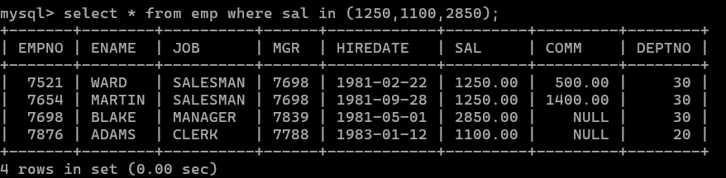

- To list all employees with sal>1250 and <2850
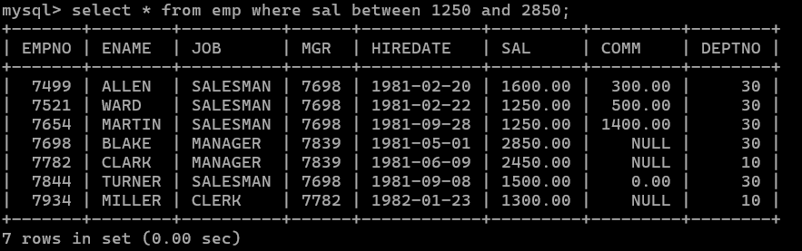
- To list all employees with name ends with AS
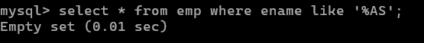

- To list all employees with job starts with C and ends with K
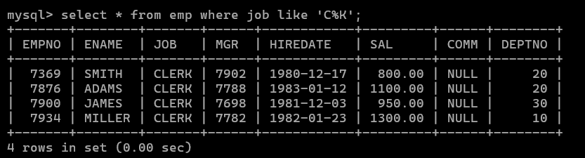

- To list all employees with job contains L at third position and M at third last position
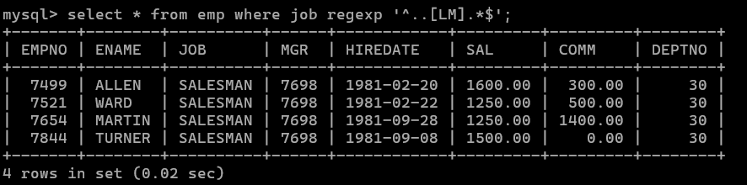

- To list all the record with sal not equal to 1250 or 1100 or 2850
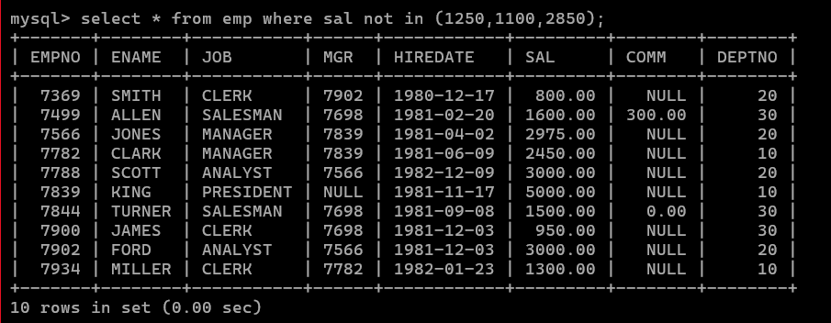
- To list all employees with salnot >1250 and <2850
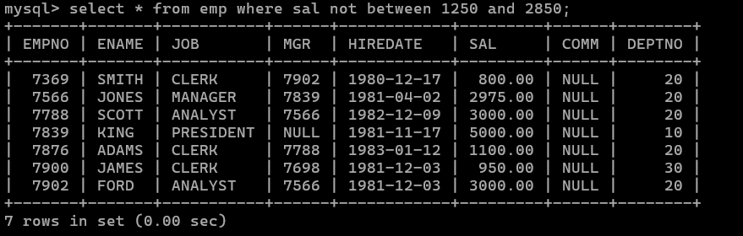

- To list all employees with job starts with C , E at 3rd position and ends with K
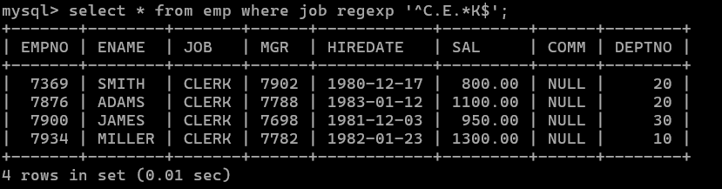

- To list all rows with comm is null
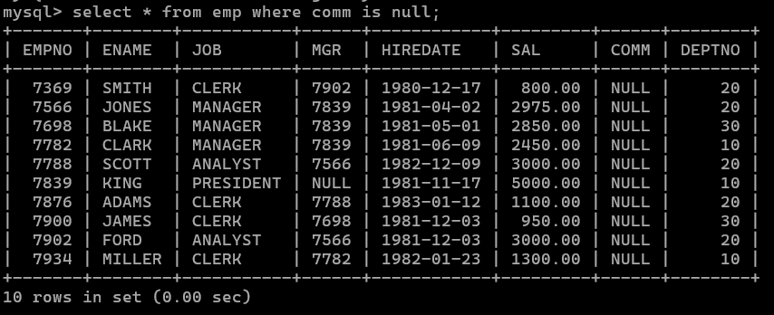

- To list all employees with sal is null and name starts with ‘S’

- To list all employees with job contains 5 characters
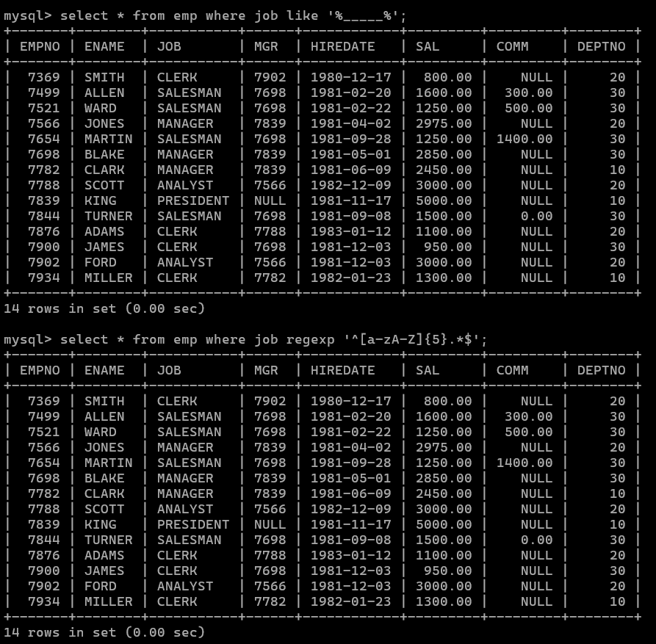

- To list all employees with name contain ‘A’ at 1 position and job Contains 5 characters
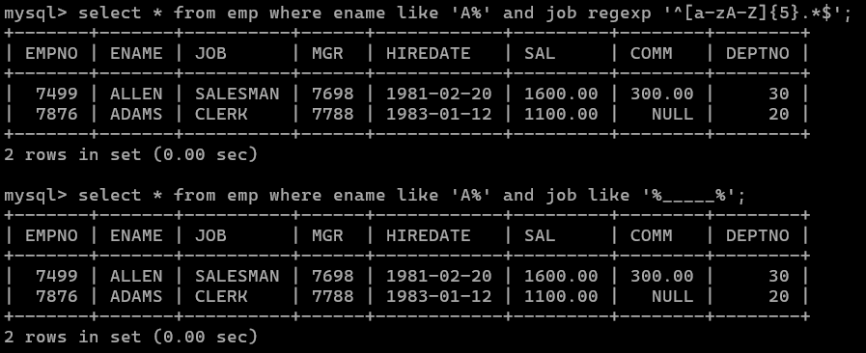

Q2. Solve the following
  - Retrieve the details (Name, Salary and dept no) of the emp who are working in department code 20, 30 and 40.
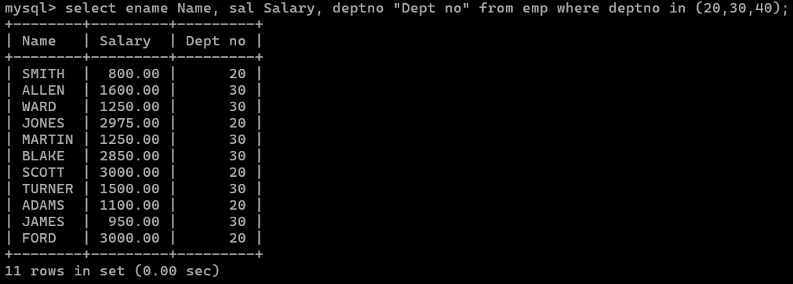
  - Display the total salary of all employees . Total salary will be calculated as sal+comm+sal*0.10
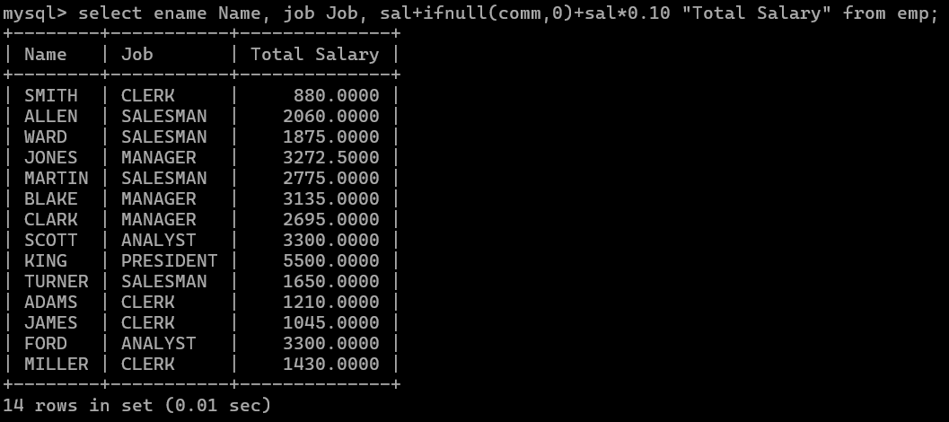

  - List the Name and job of the emp who have joined before 1 jan 1986 and whose salary range is between 1200and 2500. Display the columns with user defined Column headers.
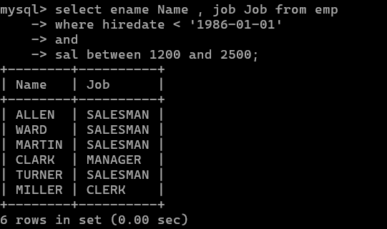
  - List the empno, name, and department number of the emp works under manager with id 7698
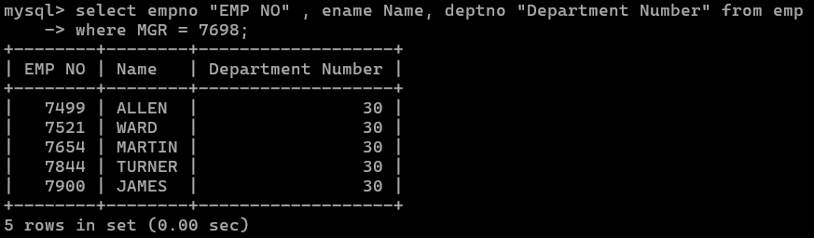

  - List the name, job, and salary of the emp who are working in departments 10 and 30.
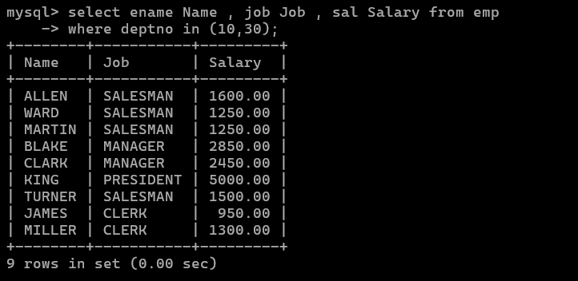

  - Display name concatenated with dept code separated by comma and space. Name the column as ‘Emp info’.
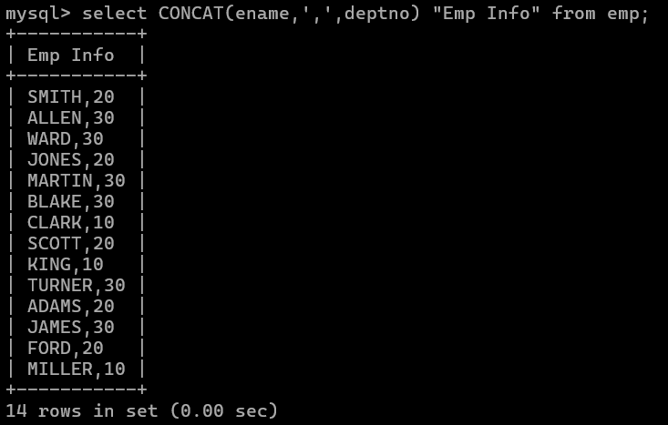

  - Display the emp details who do not have manager.
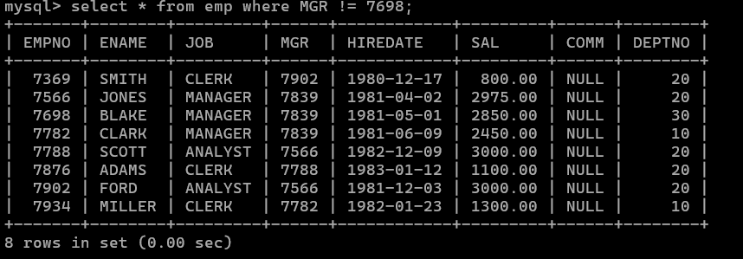

  - Write a query which will display name, department no and date of joining of all employee who were joined January 1, 1981 and March 31, 1983. Sort it based on date of joining (ascending).
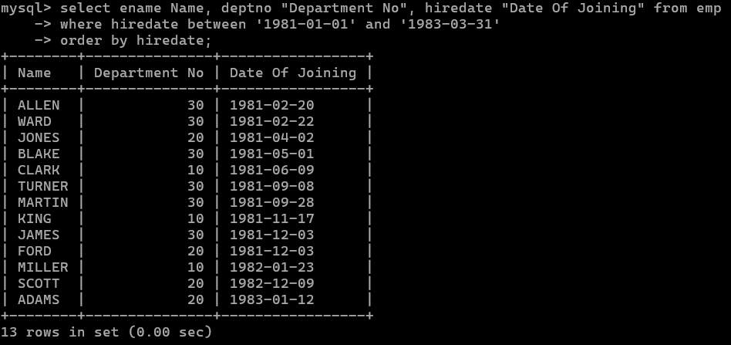

  - Display the employee details where the job contains word ‘AGE’ anywhere in the Job
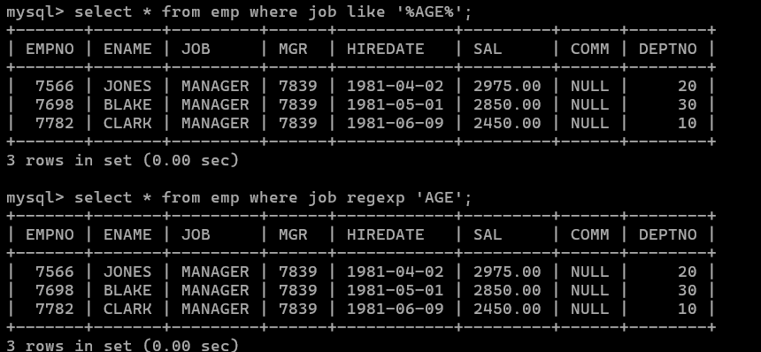

  - List the details of the employee , whose names start with ‘A’ and end with ‘S’ or whose names contains N as the second or third character, and ending with either ‘N’ or ‘S’.
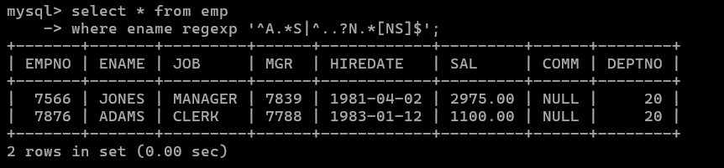

  - List the names of the emp having ‘_’ character in their name.
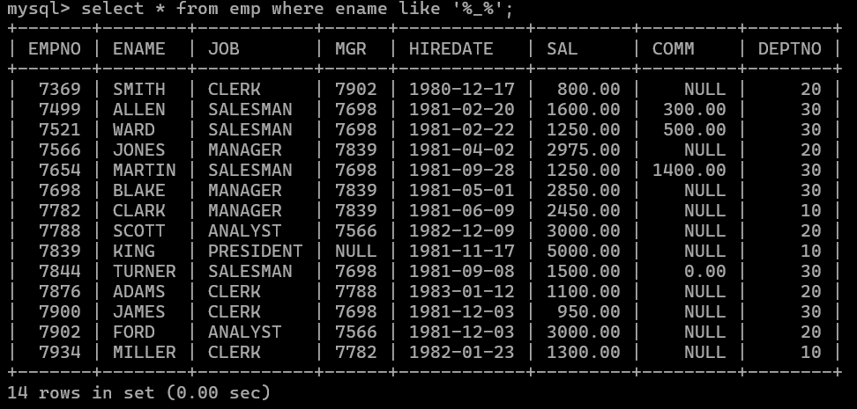
Group functions
- Display the Highest, Lowest, Total & Average salary of all employee. Label the columns Maximum, Minimum, Total and Average respectively for each Department. Also round the result to the nearest whole number.
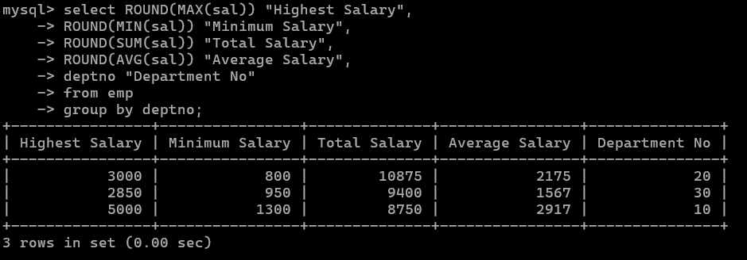
- Display Department no and number of managers working in that department. Label the column as ‘Total Number of Managers’ for each department.
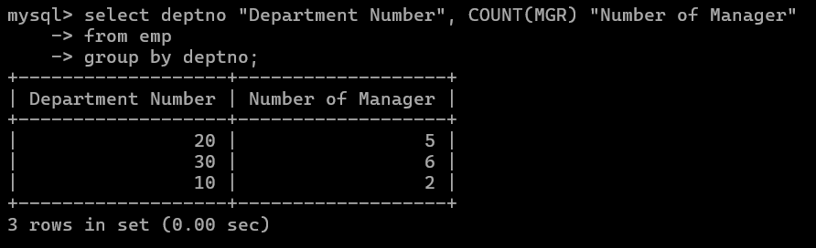
- Get the Department number, and sum of Salary of all non managers where the sum is greater than 6500

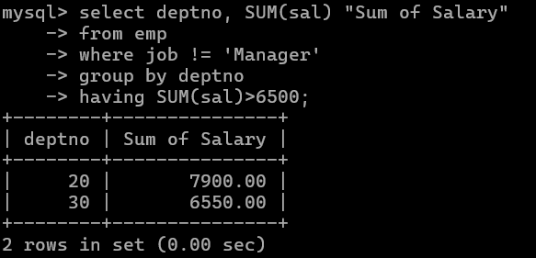

Date and Time functions

- Write a query to display the first day of the month (in datetime format) three months before the current month.
Sample current date : 2014-09-03
Expected result : 2014-06-01
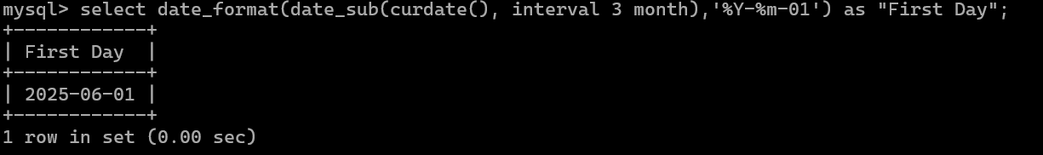
- Write a query to display the last day of the month (in datetime format) three months before the current month.
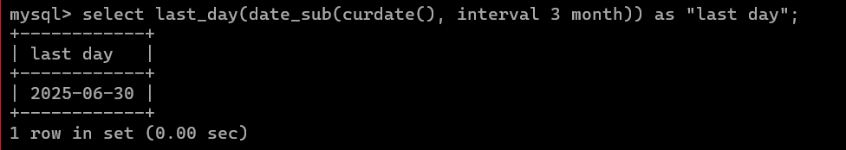
- Write a query to get the distinct Mondays from hiredate in emp tables.
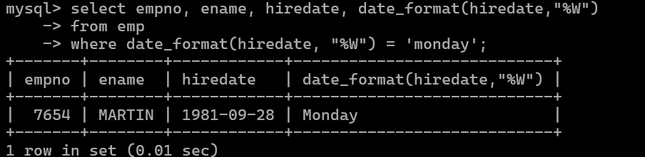

- Write a query to get the first day of the current year.
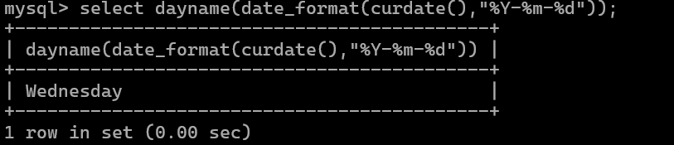
- Write a query to get the last day of the current year.
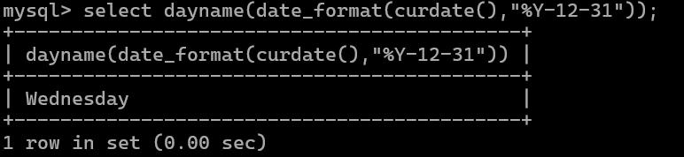

- Write a query to calculate your age in year.
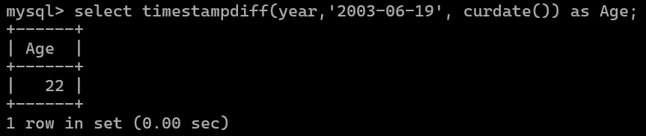

- Write a query to get the current date in the following format.
Sample date : 04-sep-2014
Output : September 4, 2014
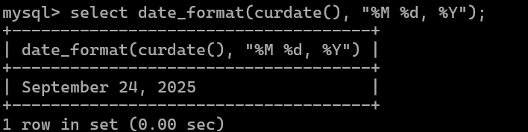

- Write a query to get the current date in Thursday September 2014 format. Thursday September 2014
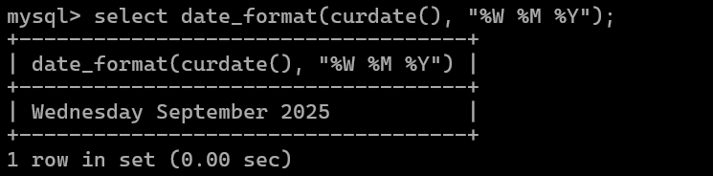

- Write a query to extract the year from the current date.
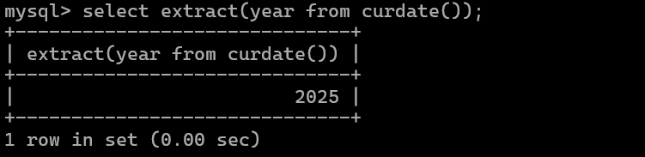

- Write a query to get the first name and hire date from employees table where hire date between '1987-06-01' and '1987-07-30'

- Write a query to display the current date in the following format. Sample output: Thursday 4th September 2014 00:00:00
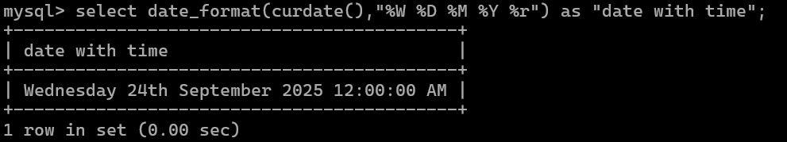

- Write a query to display the current date in the following format. Sample output: 05/09/2014
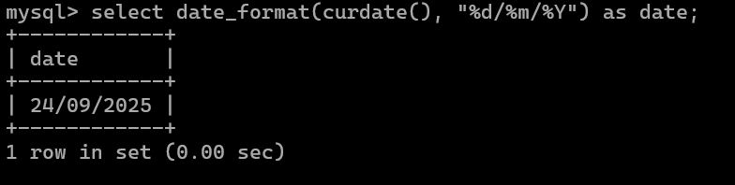
- Write a query to display the current date in the following format. Sample output: 12:00 AM Sep 5, 2014
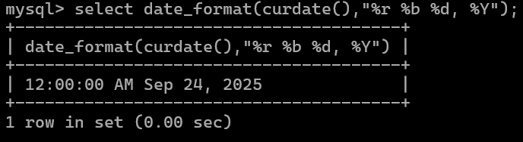

- Write a query to get the employees who joined in the month of June.

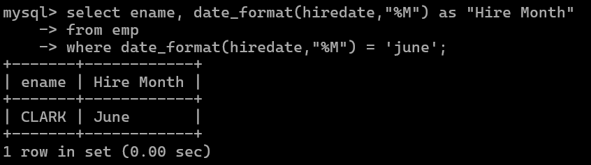

- Write a query to get the years in which more than 10 employees joined.
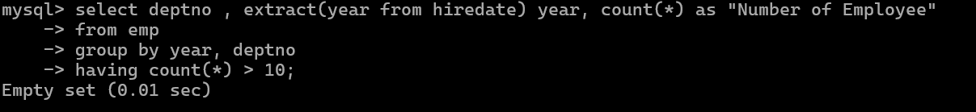
- Write a query to get first name of employees who joined in 1981.

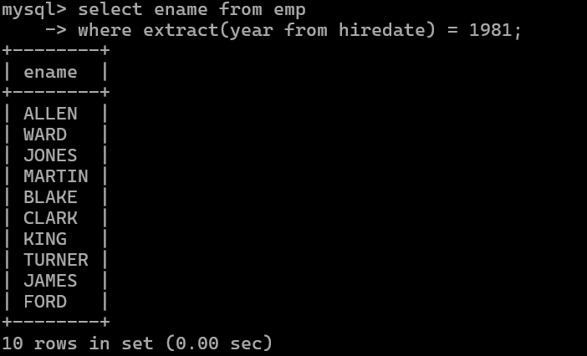

- Write a query to get employees whose experience is more than 5 years.

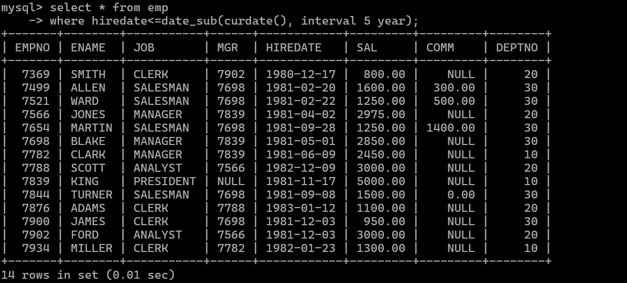

- Write a query to get employee ID, last name, and date of first salary of the employees.
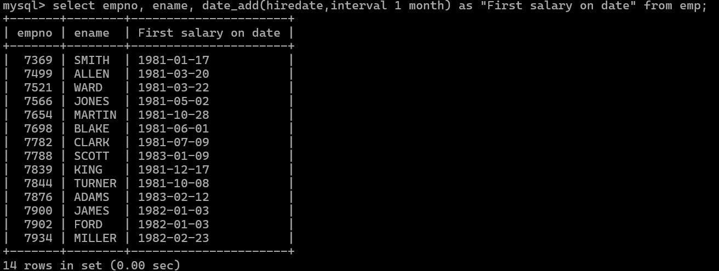

- Write a query to get first name, hire date and experience of the employees.
Sample table: employees
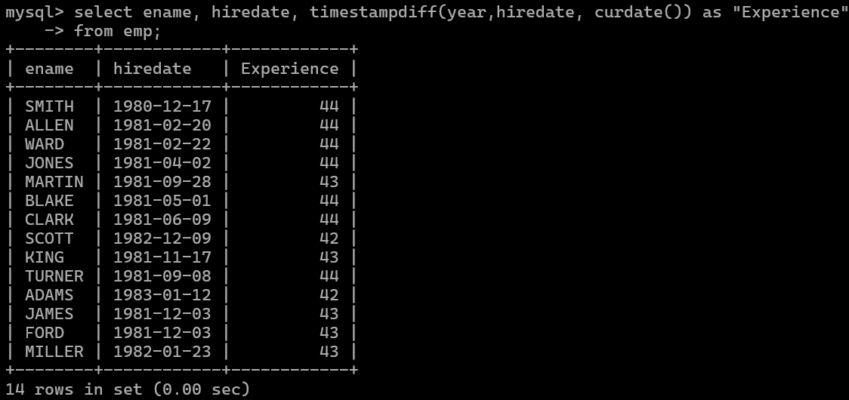

- Write a query to get the department ID, year, and number of employees joined.

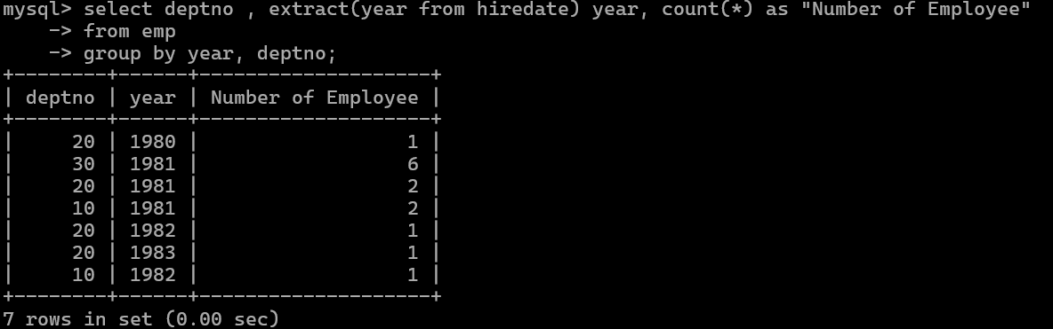

Following are the tables:
BRANCH (BID INTEGER, BRNAME CHAR (30), BRCITY CHAR (10))
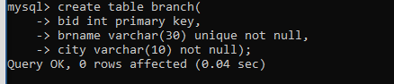
CUSTOMER (CNO INTEGER, CNAME CHAR (20), CADDR CHAR (35), CITY CHAR(20))
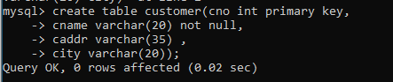
LOAN_APPLICATION (LNO INTEGER, LAMTREQUIRED MONEY, LAMTAPPROVED MONEY, L_DATE DATE)
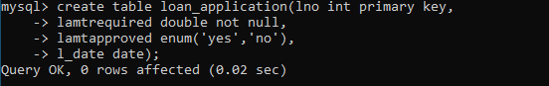
The relationship is as follows:
BRANCH, CUSTOMER, LOAN_APPLICATION are related with ternary relationship. TERNARY (BID INTEGER, CNO INTEGER, LNO INTEGER).

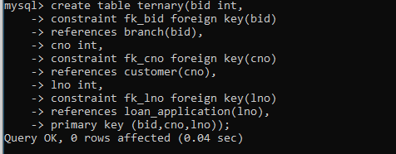

Solve the Queries
- Find the names of the customers for the “Aundh” branch.
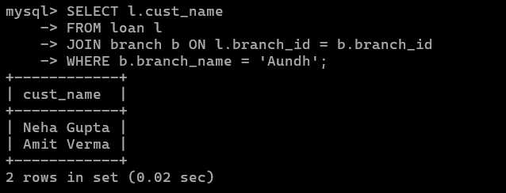

- List the names of the customers who have received loan less than their requirement.

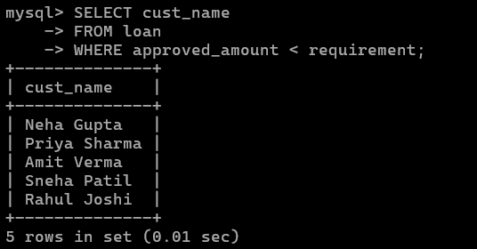

- Find the maximum loan amount approved.
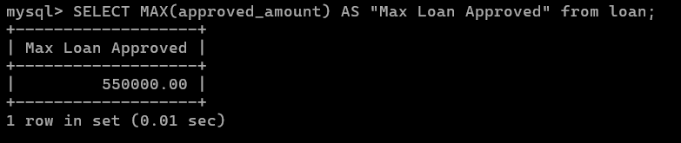

- Find out the total loan amount sanctioned by “Deccan “branch.
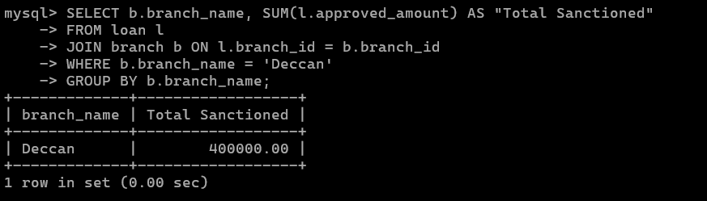

- Count the number of loan applications received by “M.G.ROAD” branch.
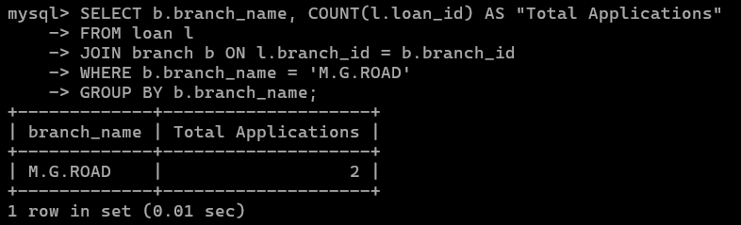

- List the names of the customer along with the branch names who have applied for loan in the month of September.

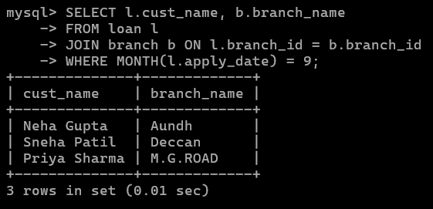

Following are the tables:
BRANCH (BID INTEGER, BRNAME CHAR (30), BRCITY CHAR (10))
CUSTOMER (CNO INTEGER, CNAME CHAR (20), CADDR CHAR (35), CITY CHAR(20))
LOAN_APPLICATION (LNO INTEGER, LAMTREQUIRED MONEY, LAMTAPPROVED MONEY, L_DATE DATE)
The relationship is as follows:
BRANCH, CUSTOMER, LOAN_APPLICATION are related with ternary relationship. TERNARY (BID INTEGER, CNO INTEGER, LNO INTEGER).
Solve the Queries
- Find the names of the customers for the “Aundh” branch.
- List the names of the customers who have received loan less than their requirement.
- Find the maximum loan amount approved.
- Find out the total loan amount sanctioned by “Deccan “branch.
- Count the number of loan applications received by “M.G.ROAD” branch.
- List the names of the customer along with the branch names who have applied for loan in the month of September.

mysql> create table branch(
-> bid int primary key,
-> brname varchar(30) unique not null,
-> city varchar(10) not null);
Query OK, 0 rows affected (0.04 sec)

> create table customer(cno int primary key,
-> cname varchar(20) not null,
-> caddr varchar(35) ,
-> city varchar(20));
Query OK, 0 rows affected (0.02 sec)

> create table loan_application(lno int primary key,
-> lamtrequired double not null,
-> lamtapproved enum('yes','no'),
-> l_date date);

> create table ternary(bid int,
-> constraint fk_bid foreign key(bid)
-> references branch(bid),
-> cno int,
-> constraint fk_cno foreign key(cno)
-> references customer(cno),
-> lno int,
-> constraint fk_lno foreign key(lno)
-> references loan_application(lno),
-> primary key (bid,cno,lno));
Write SQL statement for the following
- To find all managers with salary >1500
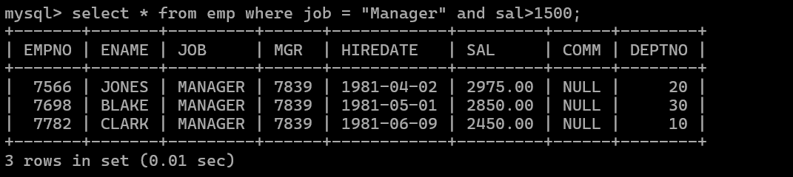
- list all employees with sal >1200 and < 2000
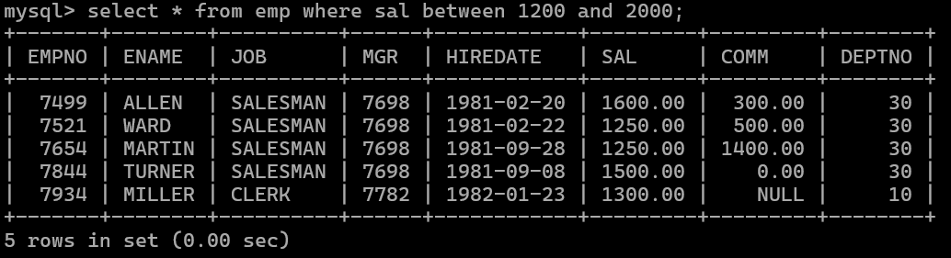
- list all employees with sal is 1600 or sal is 800 or sal is 1900
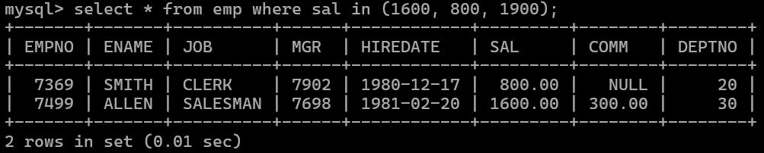
- list all employees with R at second last position in name
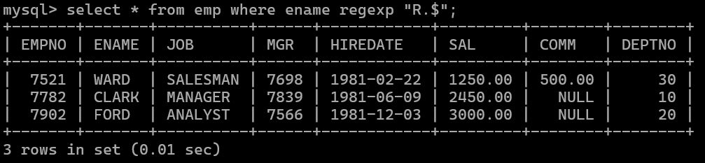

5. List all employees with name starts with A and ends with N
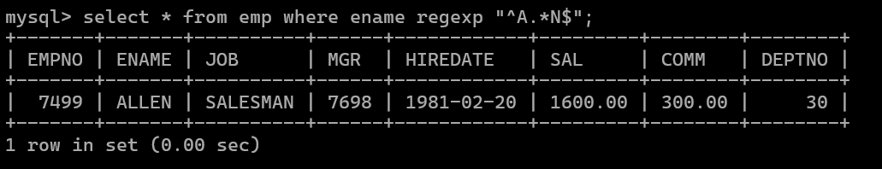

Q2. Solve following
- list all employees with salary > 1250 and dept no=30
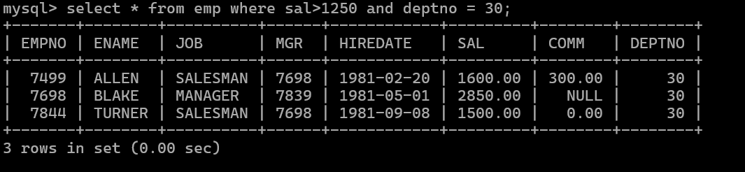

- list all employees with salary >=1250 and <= 3000
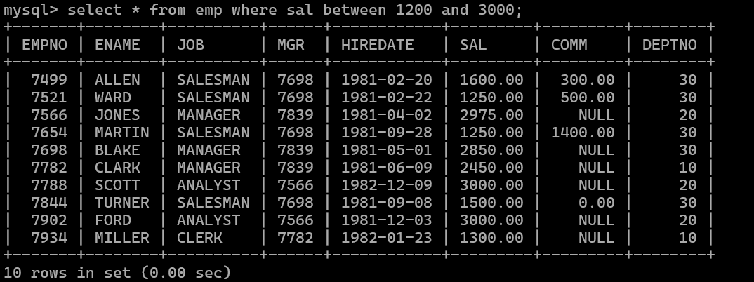

- list all employees with salary >1250 and < 3000
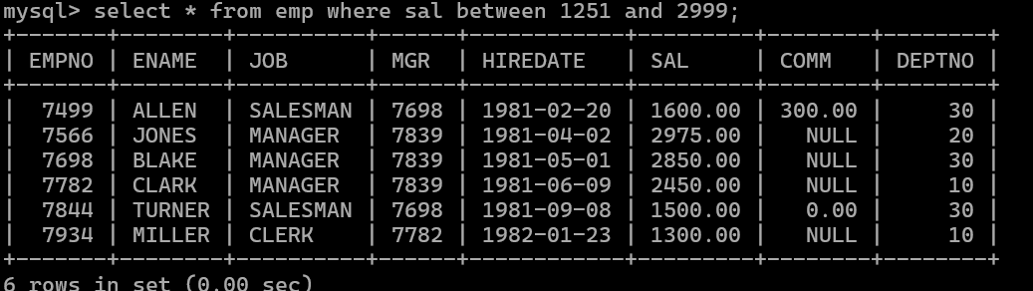

- list all employees with salary either equal to 3000 or 1250 or 2500
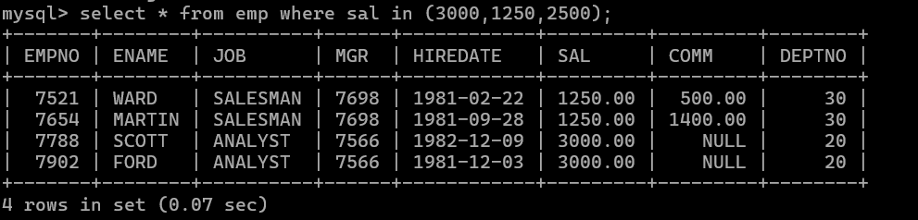
- list all employee with name=SMITH
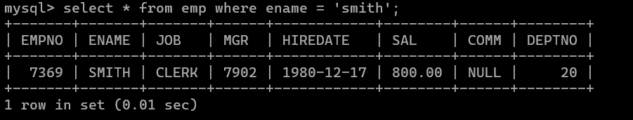
- list all employees with name starting with S
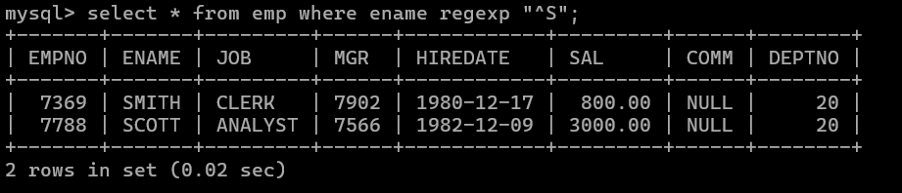
- list all employees with name ending with S
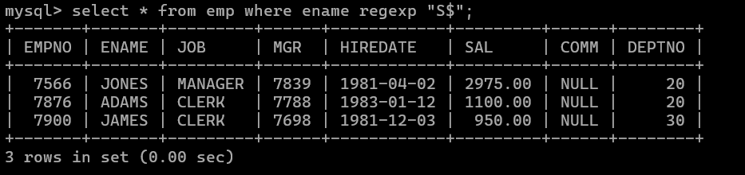
- list all employees with name contains I at 2nd position
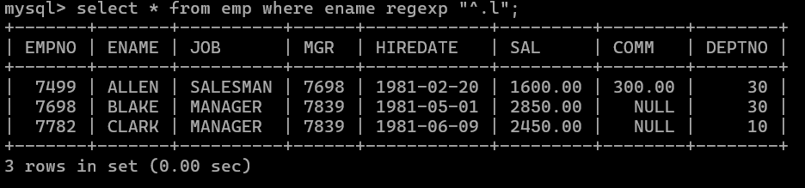
- list all employees with name starts with A ends witn N and somewhere in between L is there
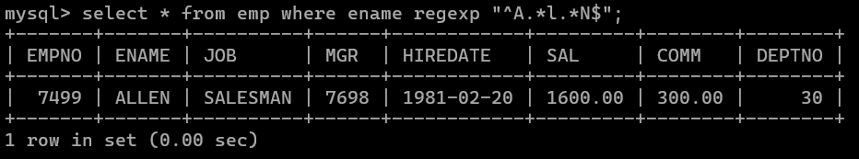
- list all employees with name starts with A and B at 3 rd position and P at second last position
- List all employees with name starts with either A or starts with S or starts with W
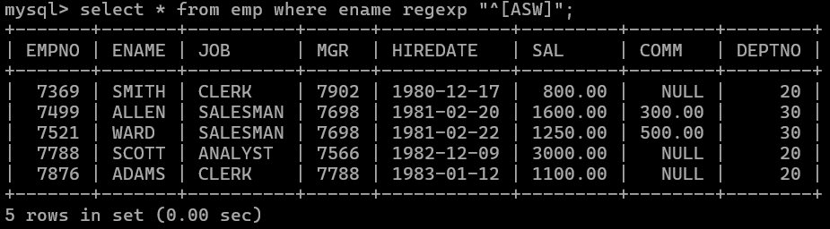

- find max sal and min sal for each job
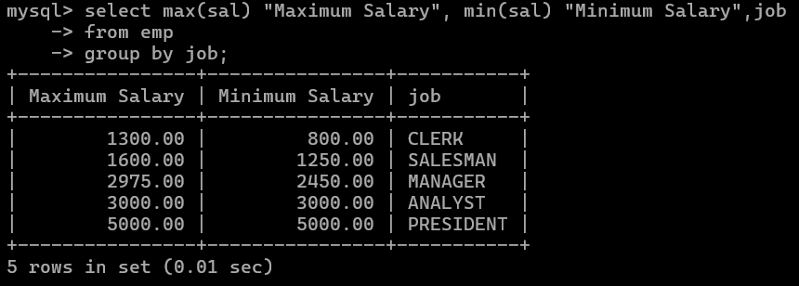
- find how many employess have not received commission
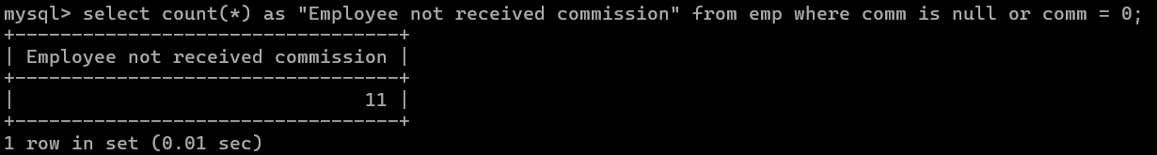
- find sum of sal of all employees working in dept no 10
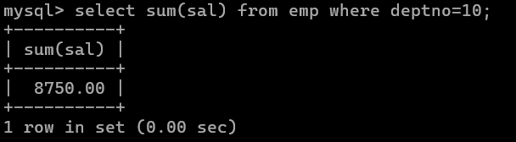
- find maximum salary,average sal for each job in every department
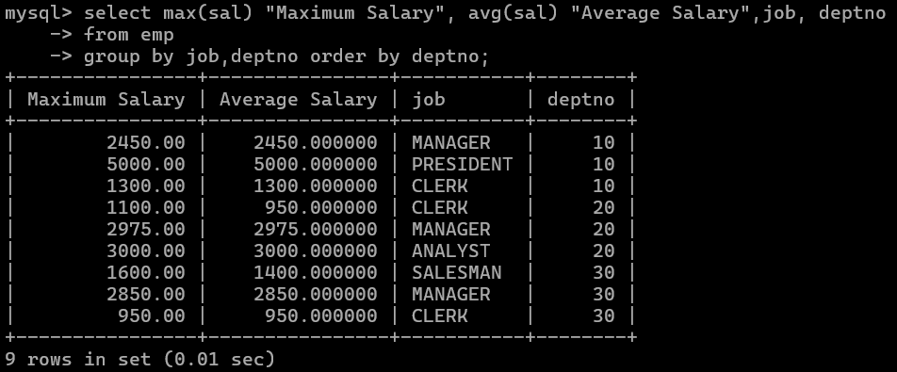

- find max salary for every department if deptno is > 15 and arrange data in deptno order.
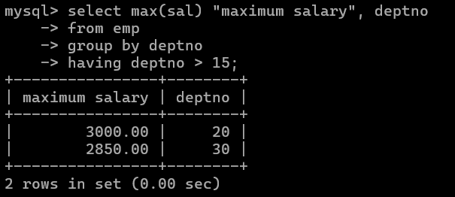
- find sum salary for every department if sum is > 3000
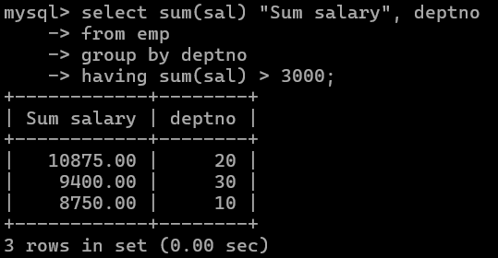
- list all department which has minimum 5 employees
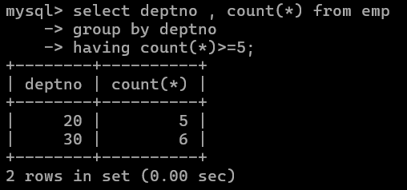

- count how many employees earn salary more than 2000 in each job
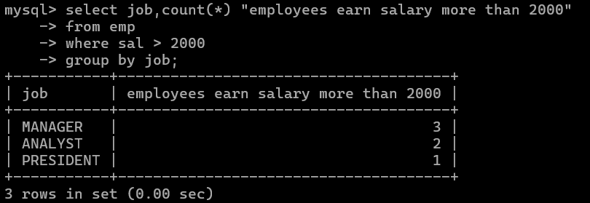
- list all enames and jobs in small case letter
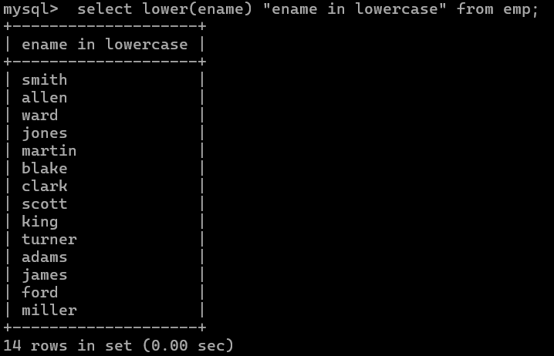

- list all names and jobs so that the length of name should be 15 if it is samller then add spaces to left.
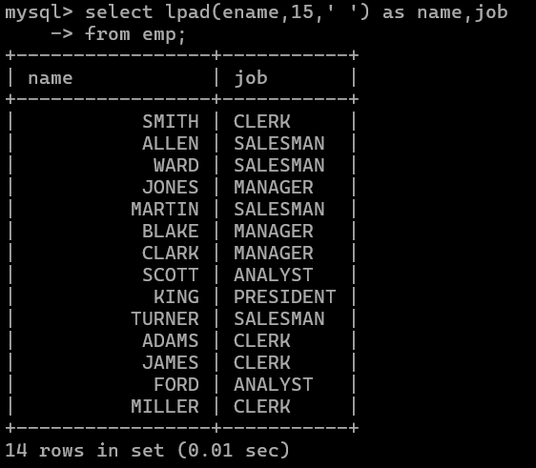
- display min sal,max sal, average sal for all employees working under same manager

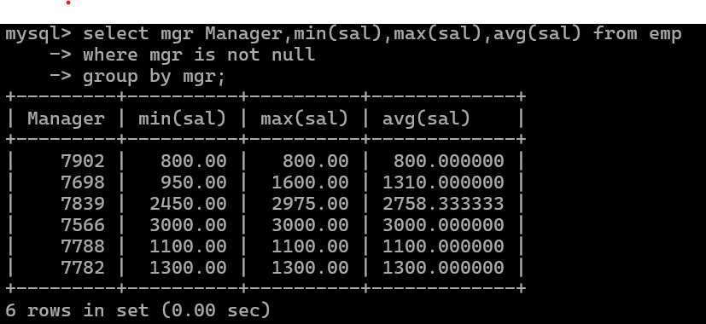

- find sum of total earnings(sal+comm), average of sal+comm for all employees who earn sal > 2000 and work in either dept no 10 or 20
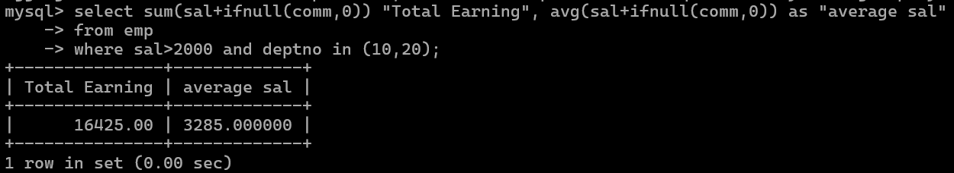
- list all employees who joined in Aug 1980 and salary is >1500 and < 2500
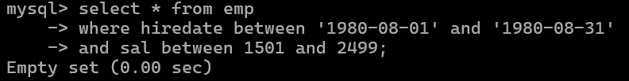
- list all employees joined in either aug or may or dec
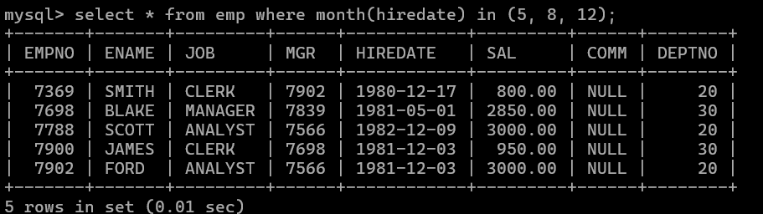
- display name and hiredate in dd/mm/yy format for all employees whose job is clerk and they earn some commission
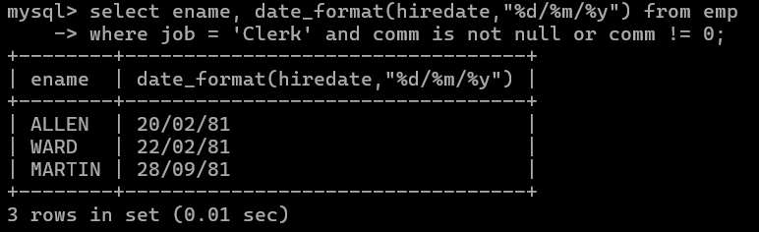
- list empcode,empno,name and job for each employee. (note :empcode is 3 to 5 characters from name and last 2 characters of job)
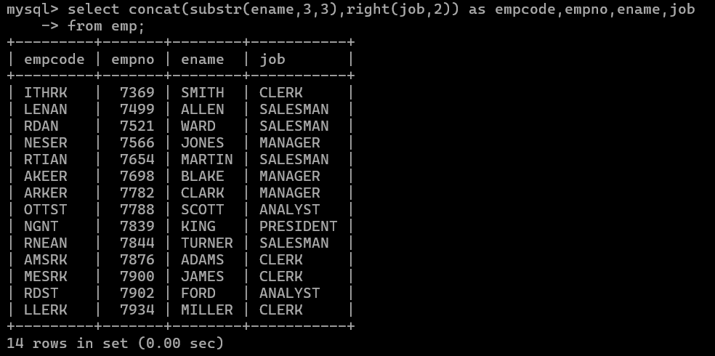

- display thousand separator and $ symbol for commission if it is null then display it as 0 for all employees whose name starts with A and ends with N
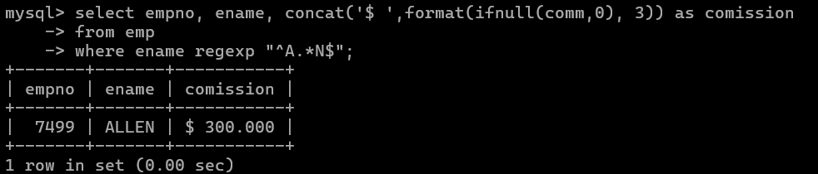

- Display empid,name,sal,comm,remark Remark should base on following conditions comm >= 600 "excellent Keep it up"
if it < 600 or not null "good" otherwise "Need improvement"
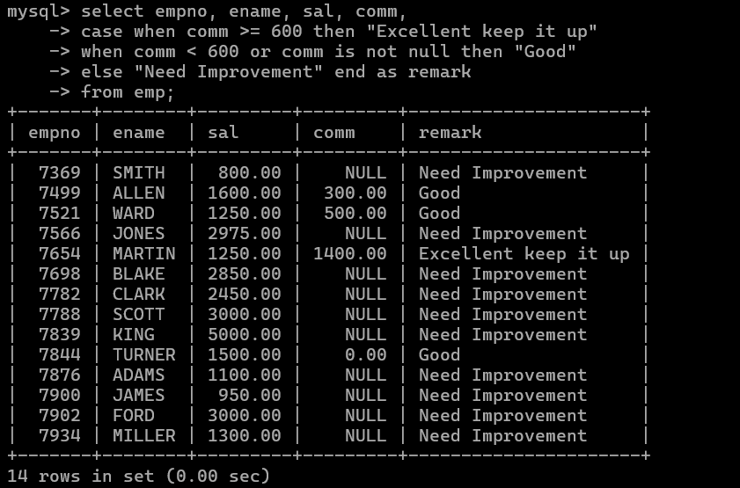

- Display empid, name, deptno and department name by using following conditions. dept 10 then "Hr"
if 20 then "Admin"
if 30 then "accounts" otherwise purchase
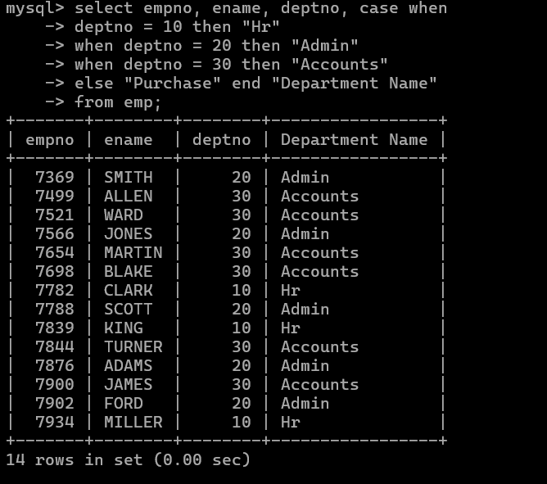
- Practice creating following tables

create table mydept_DBDA (
deptid number primary key,
dname varchar2(20) not null unique, dloc varchar2(20)
)

insert into mydept_DBDA values(30,'Purchase','Mumbai');

create table myemployee (
empno number(5) primary key, fname varchar2(15) not null, mname varchar2(15),
lname varchar2(15) not null,
sal number(9,2) check(sal >=1000), doj date default sysdate, passportnum varchar2(15) unique,
deptno number constraint fk_deptno references mydept_DBDA(deptid) on delete cascade
)

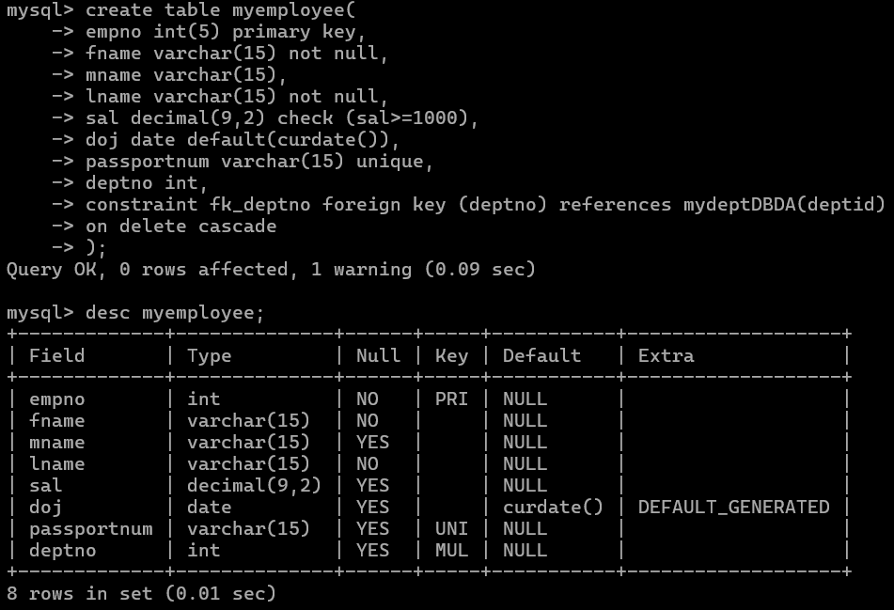

- Create following tables Student, Course
Student (sid,sname) ---------------- sid ---primary key
Course(cid,cname)-------------- cid ---primary key

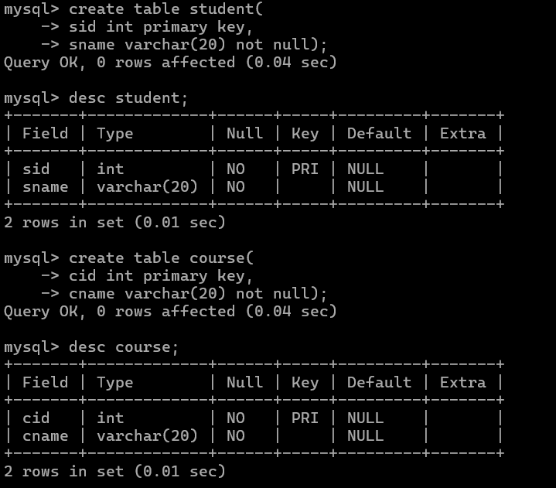

Marks(studid,coursed,marks) Sample data for marks table studid,courseid,marks
1 | 1 | 99
1 | 3 | 98
2 | 1 | 95
2 | 2 | 97

create table marks( studid number, courseid number, marks number,
constraint pk primary key(studid,courseid),
constraint fk_sid foreign key (studid) references student(sid) on delete set null, constraint fk_cid foreign key (courseid) references course(cid)
)
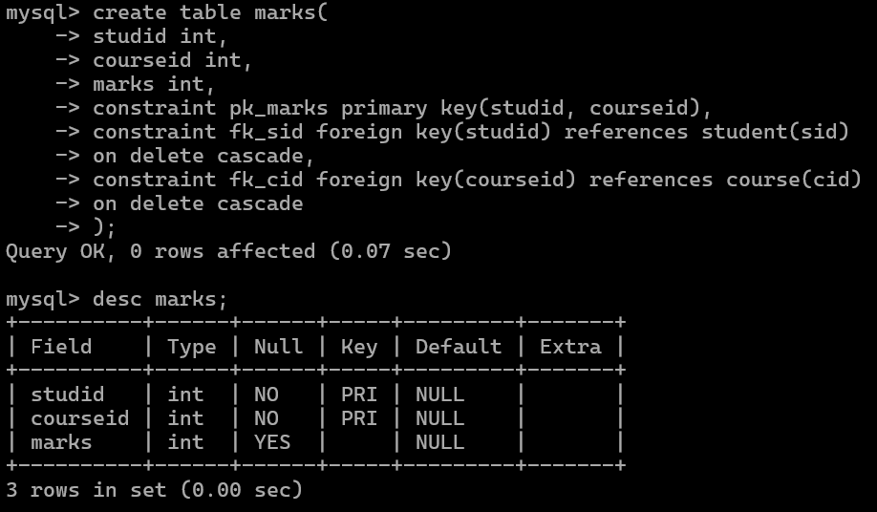
- Create empty table emp10 with table structure same as emp table. create table emp10 as
(
select * from emp where 1=2;
)

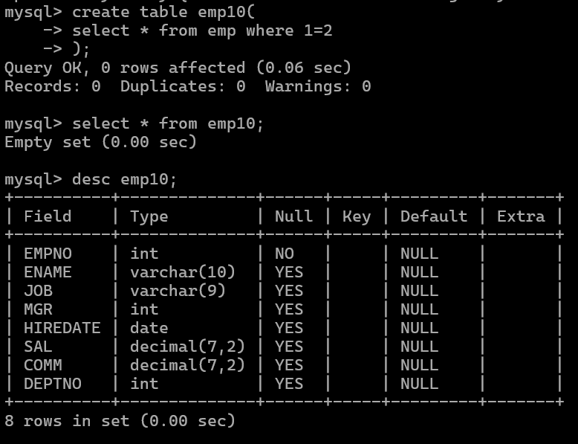

- Solve following using alter table
add primary key constraint on emp,dept,salgrade emp ----→ empno
dept---→ deptno salgrade---→ grade
add foreign key constarint in emp deptno --->> dept(deptno)
add new column in emp table netsal with constraint default 1000
Answer:
alter table emp add constraint pk_emp primary key(empno);
alter table dept add constraint pk_dept primary key(deptno);
alter table salgrade add constraint pk_sal primary key(grade);

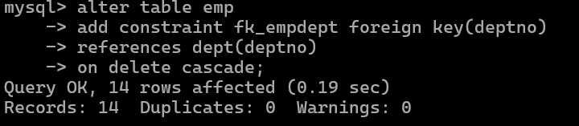

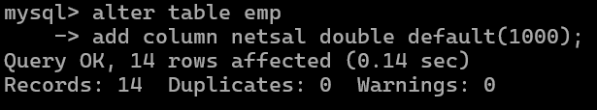

- Update employee sal increase sal of each employee by 15 % sal +comm, change the job
to manager and mgr to 7777 for all employees in deptno 10.
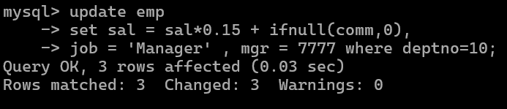
- change job of smith to senior clerk
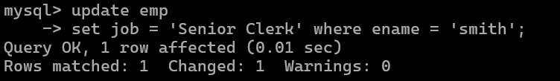

- increase salary of all employees by 15% if they are earning some commission
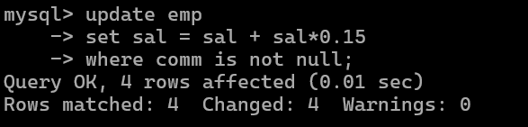

- list all employees with sal>smith's sal
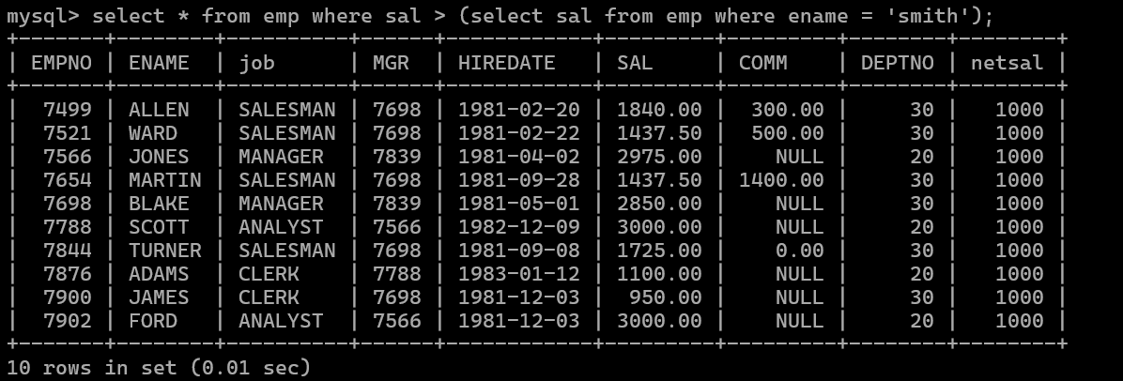
- list all employees who are working in smith's department
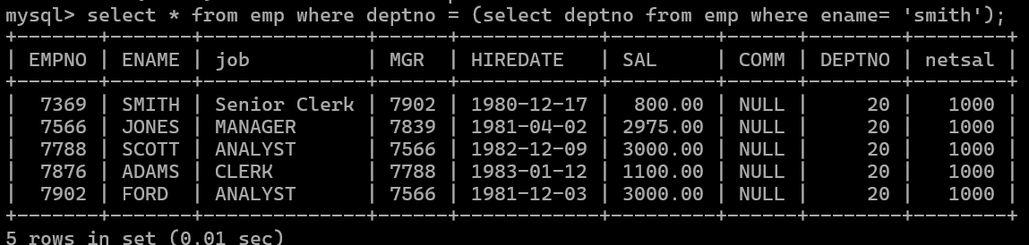
- list all employees with sal < rajan's sal and salary > revati's sal
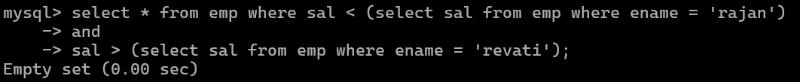
- delete all employees working in alan's department
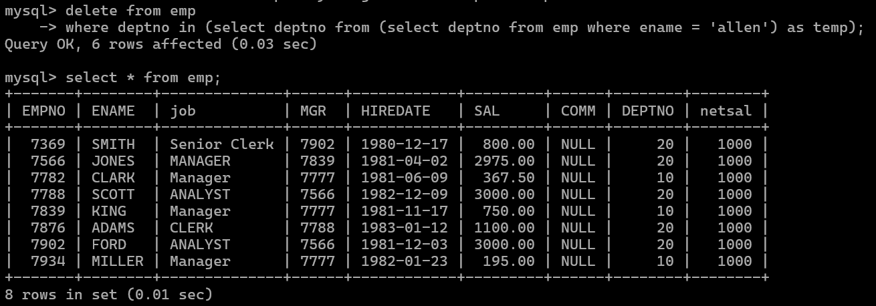
- change salary of Alan to the salary of Miller.
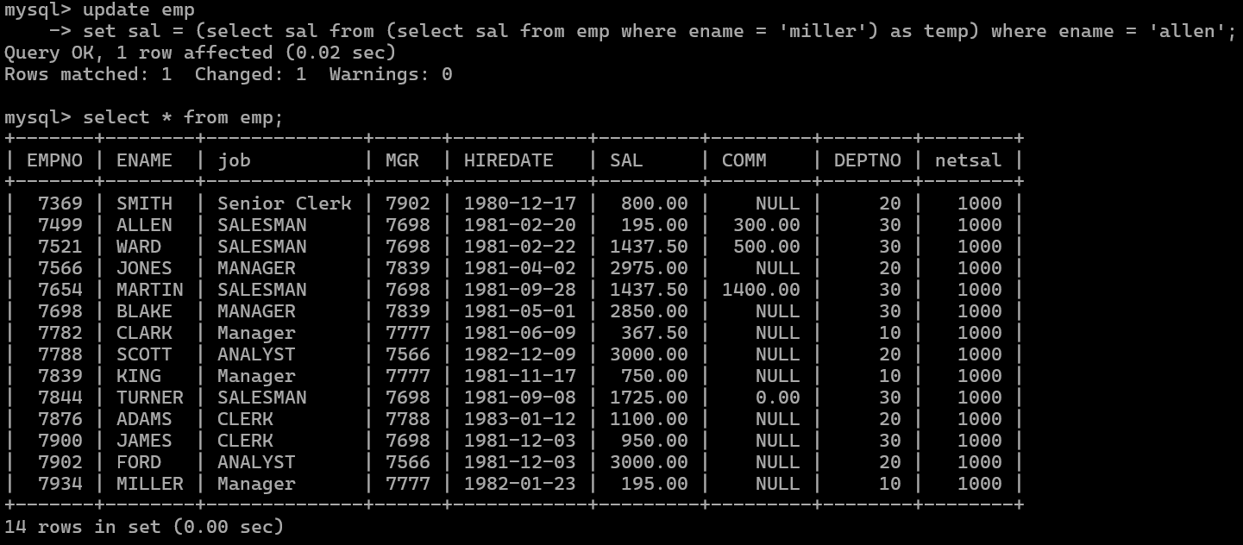

- change salary of all employees who working in Ward's department to the salary of Miller.
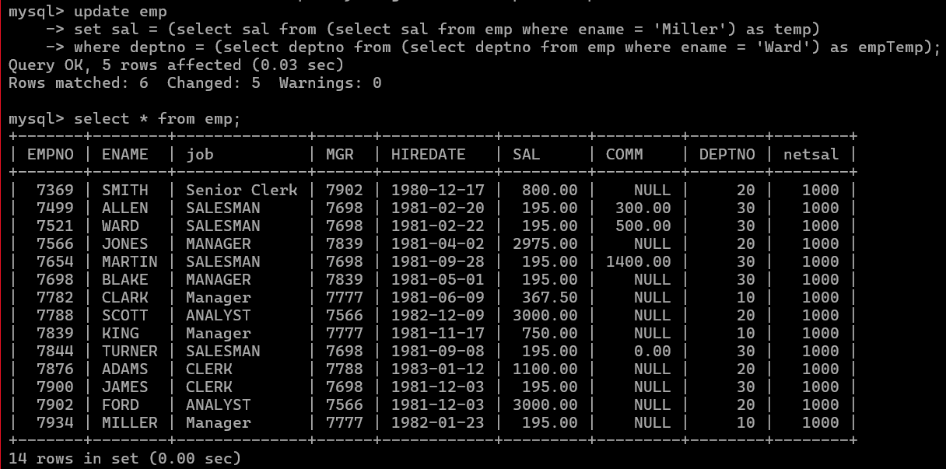
- list all employees with salary > either Smith's salary or alan's sal
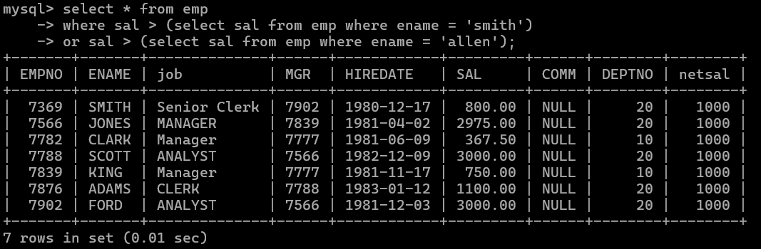
- list all employees who earn more than average sal of dept 10
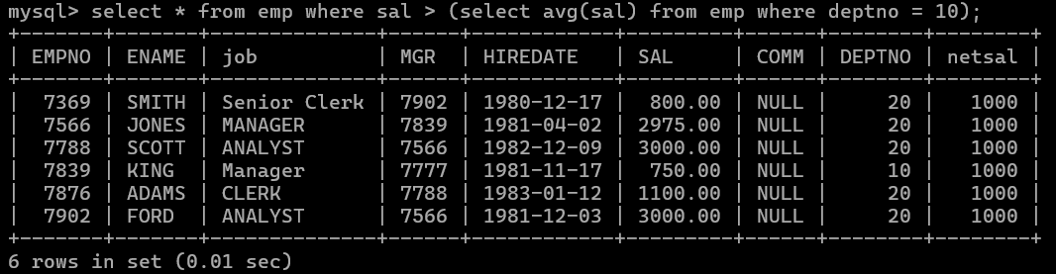
- list all employees who earn more than average sal of Alan's department
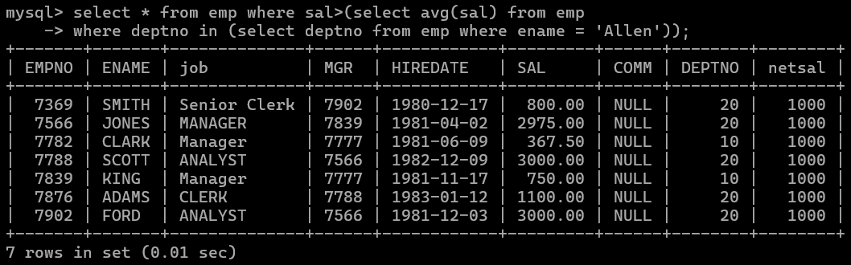

- list all employees who are working in purchase department

- list all employees who earn more than average salary of their own department

- list all employees who earn sal < than their managers salary
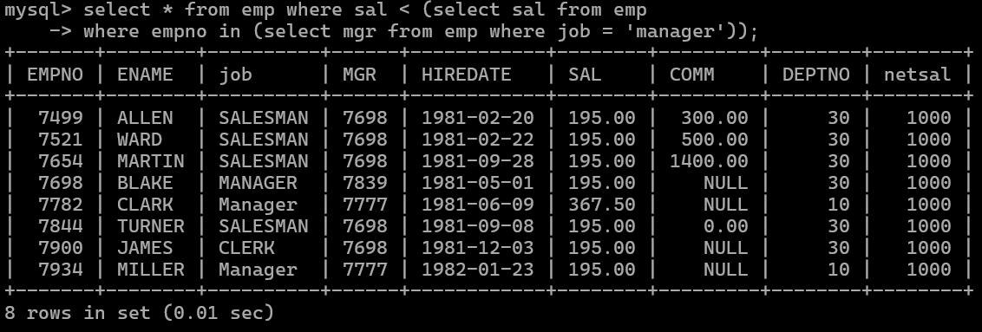
- list all employees who are earning more than average salary of their job
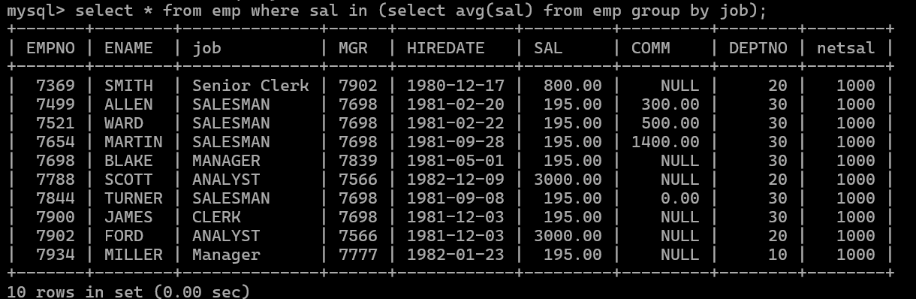

- display employee name and department
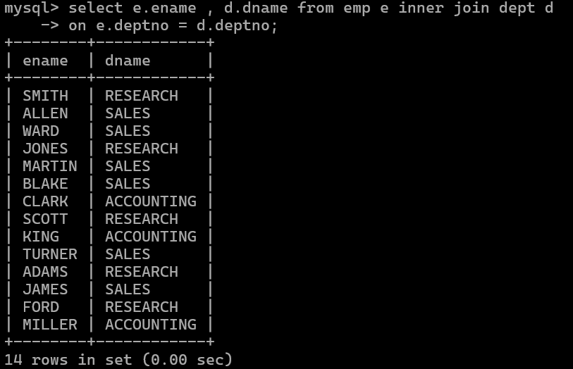
- display empno,name,department name and grade (use emp,dept and salgrade table)
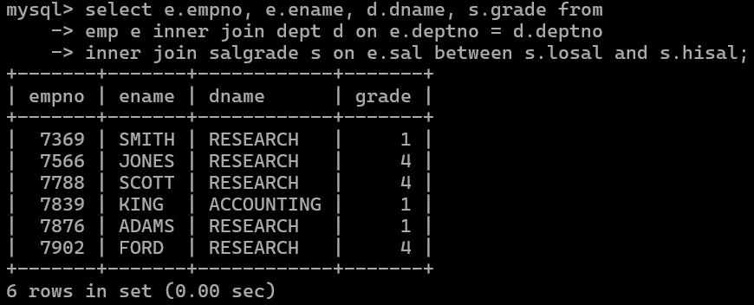
- list all employees number,name, mgrno and manager name
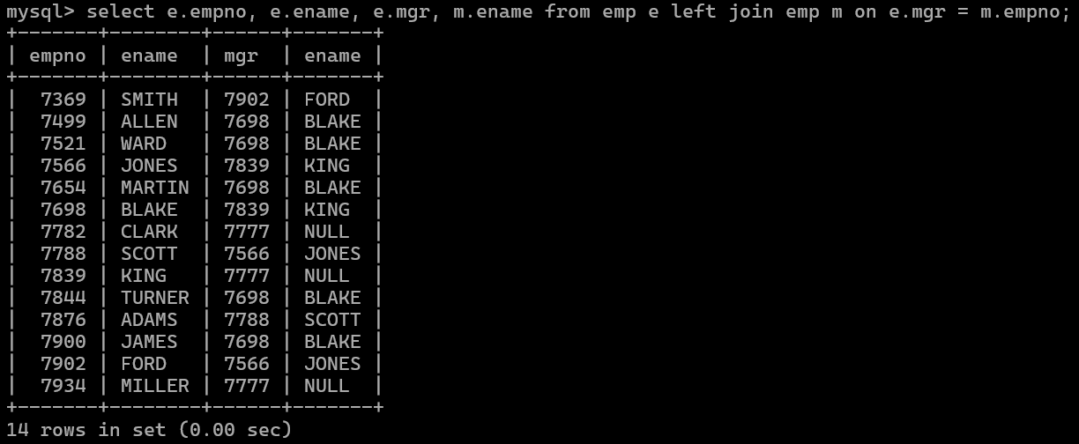

- create following tables and solve following questions(primary keys are marked in yellow) foreign keys are marked in green
product(pid,pname,price,qty,cid,sid)
salesman (sid,sname,address)
category(cid,cnam,descritpion)
  - list all product name,their category name and name of a person, who sold that product
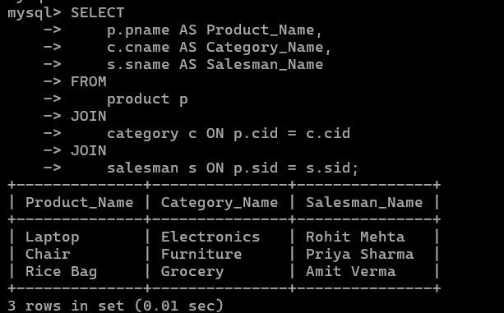
  - list all product name and salesman name for all salesman who stays in pune

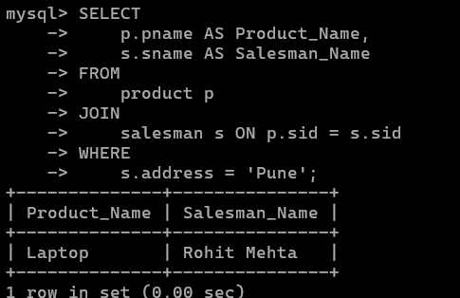
  - list all product name and category name
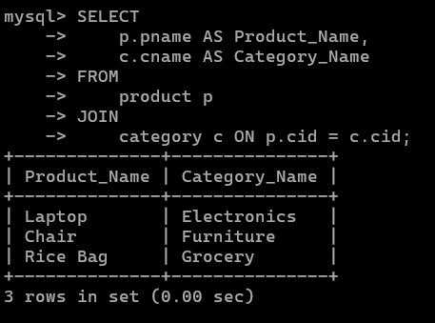

- create following tables and solve following questions(primary keys are marked in yellow) foreign keys are marked in green

faculty(fid,fname,sp.skill1,sp.skill2)
courses(cid,cname,rid,fid)
room(roomid,rname,rloc) faculty
fid fname spskill1 spskill2
- kjzhcjhz a b
- sdd x z
- lksjk a x
- ksdjlkj a b

courses
cid cname rid fid

121 | DBDA 100 10
131 | DAC 101
141 | DTISS
151 | DIOT 105 12

Room
roomid rname rloc

100 | jasmin 1st floor
101 | Rose 2nd floor
105 | Lotus 1st floor
103 | Mogra 1st floor

  - list all courses for which no room is assigned. And all rooms for which are available
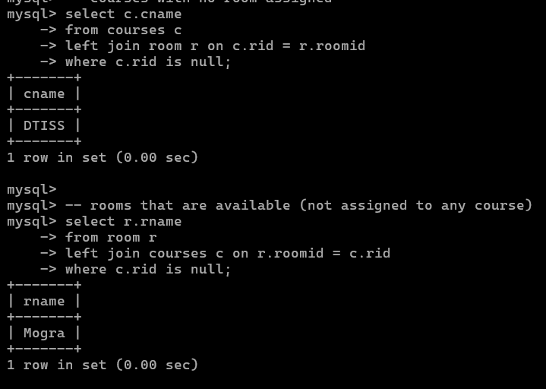

  - list all faculties who are not allocated to any course and rooms which are not allocated to any course
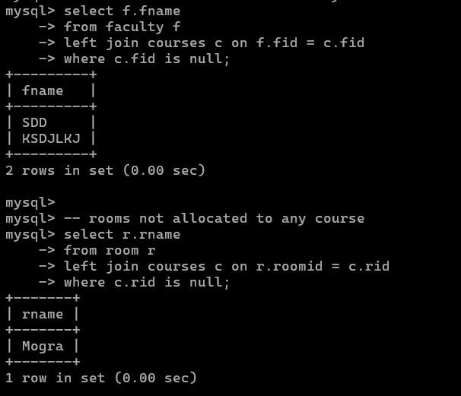
  - list all rooms which are allocated or not allocated to any courses
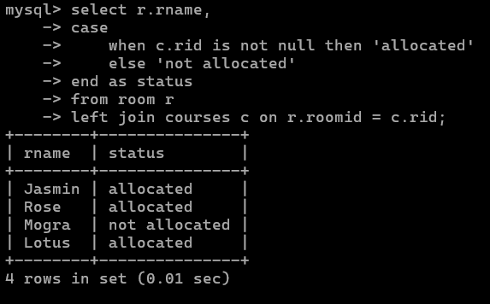

  - list all rooms which are not allocated to any courses
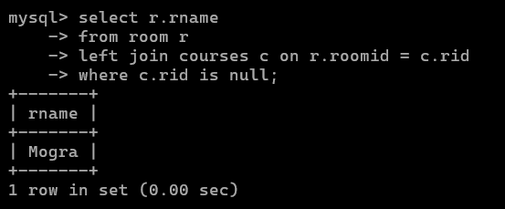

  - display courses and faculty assigned to those courses whose special skill is database
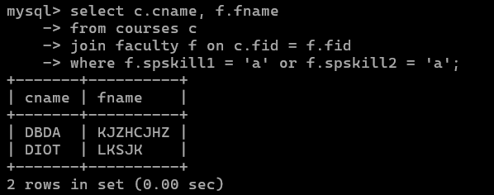
  - display time table --- it should contain course details , faculty and room details

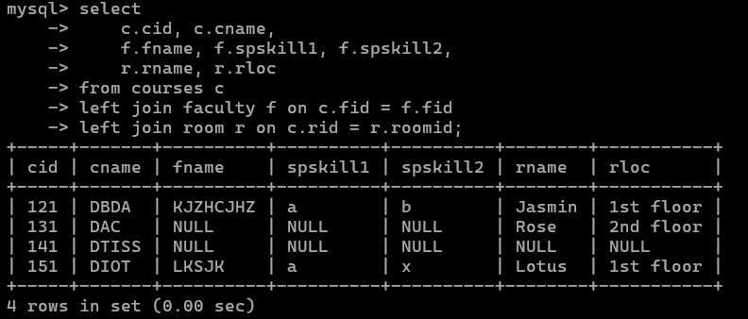

- create following tables with given constraints
product qty >0, default 20.00,pname not null and unique
prodid pname qty price catid sid

123 | lays | 30 | 30.00 | 1 | 12
111 | pepsi | 40 | 50.00 | 4 | 11
134 | nachos | 50 | 50.00 | 1 | 12
124 | dairy milk | 40 | 60.00 | 2 | 14
124 | pringles 40 | 60.00 | 1 14

saleman ----- sname not null
sid sname city
- Rahul Pune
- Kirti Mumbai
- Prasad Nashik
- Arnav Amaravati

category ---- cname unique and not null cid cname description
- chips very crunchy
- chocolate very chocolaty
- snacks yummy
- cold drinks thanda thanda cool cool
- List all products with category chips
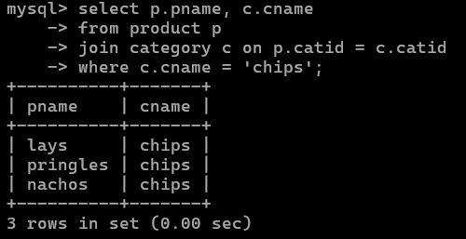

- display all products sold by kirti
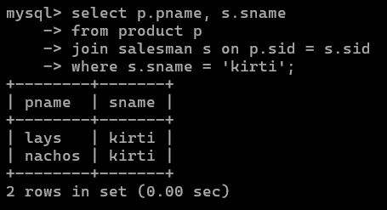
- display all salesman who do not sold any product
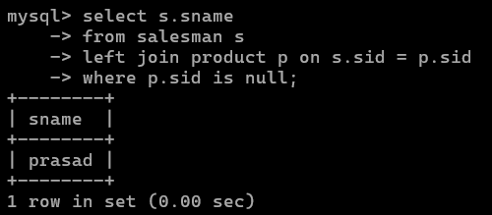
- display all category for which no product is there
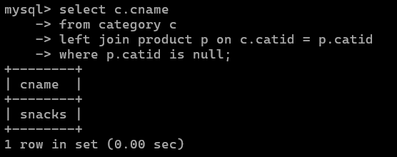
- display all products with no category assigned
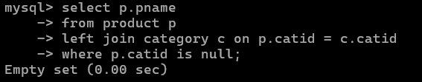
- list all salesman who stays in city with name starts with P or N
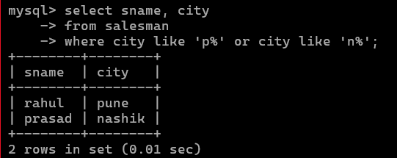
- add new column in salesman table by name credit limit
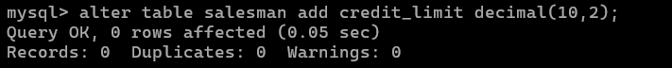

Solve the following
Loops example
1. Print the following patterns using loop :
a.
*
**
***
****

delimiter //
drop procedure displayTriangle;
create procedure displayTriangle(in num int)
begin
declare str1 varchar(100) default '*';
declare result varchar(100) default '\n';
declare count int default 1;
while count <=num do
set result = concat(result, str1, '\n');
set str1 = concat(str1,'*');
set count = count +1;
end while;
select result;
end //
delimiter ;

b.
*
***
****
***
*

delimiter //
drop procedure if exists displaydiamond;

create procedure displaydiamond(num int )
begin
declare str1 varchar(100) default "*";
declare result varchar(255) default "\n";
declare length int ;
set length = num/2;

while length <= num do
set result = concat(result,lpad(str1,length," "),"\n");
set str1 = concat(str1,"**");
set length = length +1;
end while;

set length = num-1;
set str1 = substr(str1,1,num-2);

while length >= ceil(num/2) do
set result = concat(result,lpad(str1,length," "),"\n");
set str1 = substr(str1,1,length(str1)-2);
set length = length-1;
end while;
select result;

end //
delimiter ;

c.
1010101
10101
101
1

d.
1
1 2
1 2 3
1 2 3 4
1 2 3 4 5

delimiter //

drop procedure if exists numberpattern;
create procedure numberpattern(num int )
begin
declare n1 int default 1;
declare result varchar(225) default '\n' ;
declare count int default 1;

while count <= num do

set result = concat(result," ",n1,'\n');
set n1 = concat(n1, count+1);
set count = count +1;

end while;
select result;
end //
delimiter ;

2. write a procedure to insert record into employee table.
the procedure should accept empno, ename, sal, job, hiredate as input parameter write insert statement inside procedure insert_rec to add one record into table
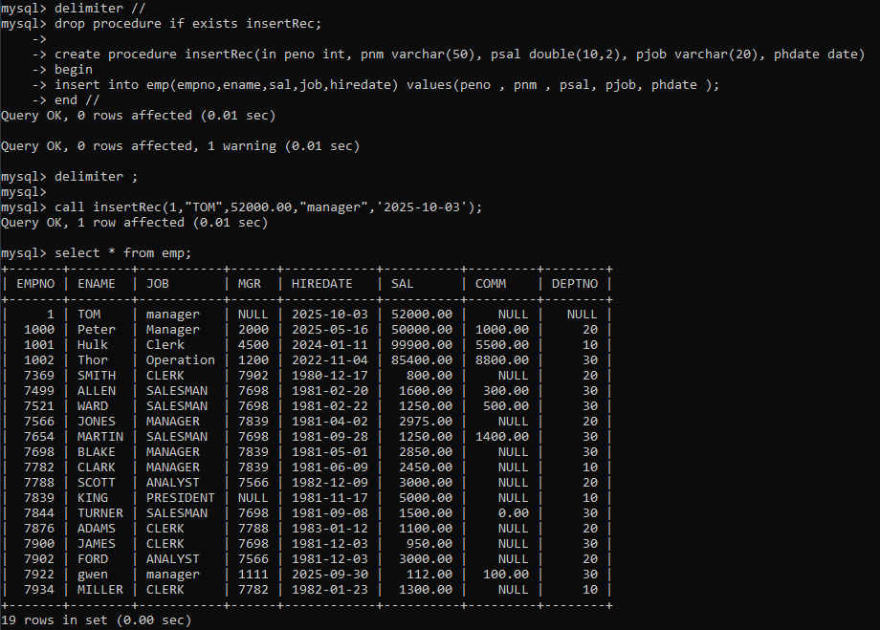

3. write a procedure to delete record from employee table.
the procedure should accept empno as input parameter.
write delete statement inside procedure delete_emp to delete one record from emp table

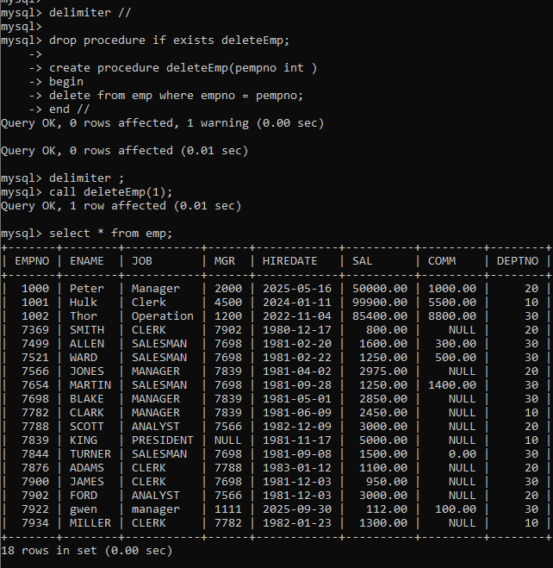

4. write a procedure to display empno,ename,deptno,dname for all employees with sal > given salary. pass salary as a parameter to procedure
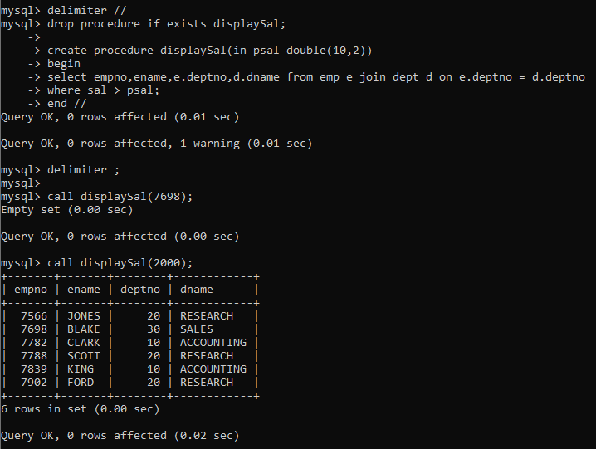

5. write a procedure to find min,max,avg of salary and number of employees in the given deptno.
deptno --→ in parameter
min,max,avg and count ---→ out type parameter
execute procedure and then display values min,max,avg and count
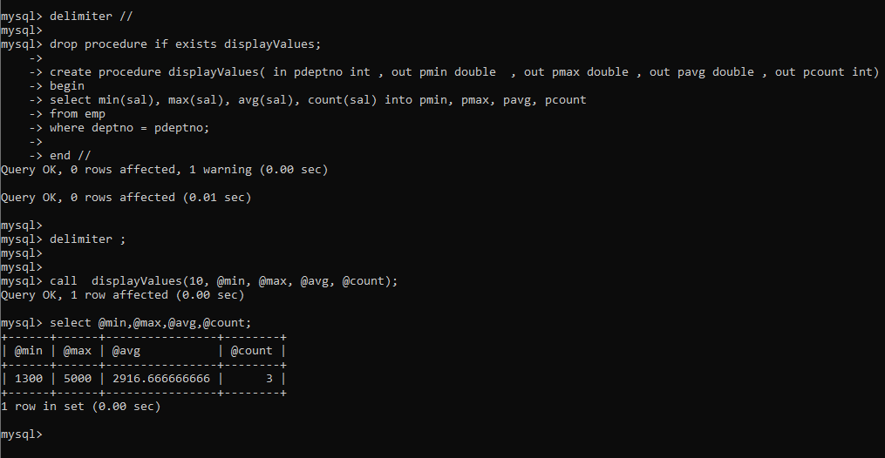
6. write a procedure to display all pid,pname,cid,cname and salesman name(use product,category and salesman table)
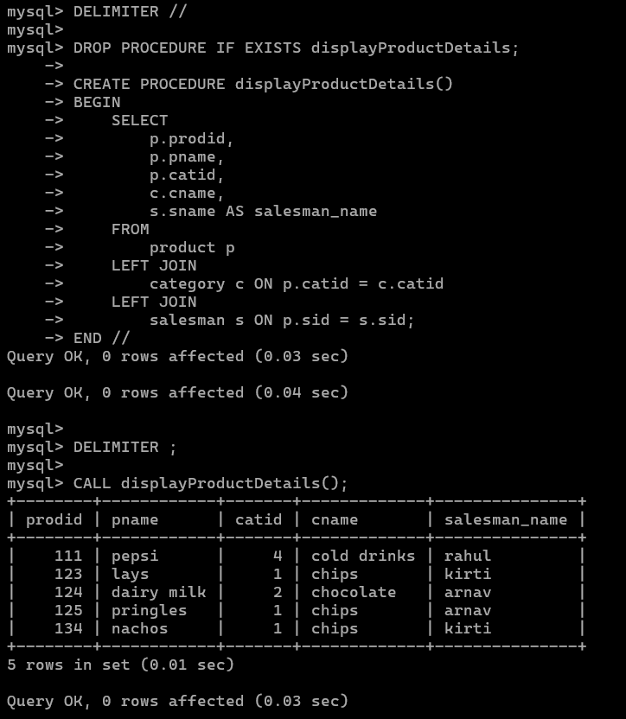

8. Write a procedure that displays the following information of all emp Empno,Name,job,Salary,Status,deptno
Note: - Status will be (Greater, Lesser or Equal) respective to average salary of their own department. Display an error message Emp table is empty if there is no matching record.

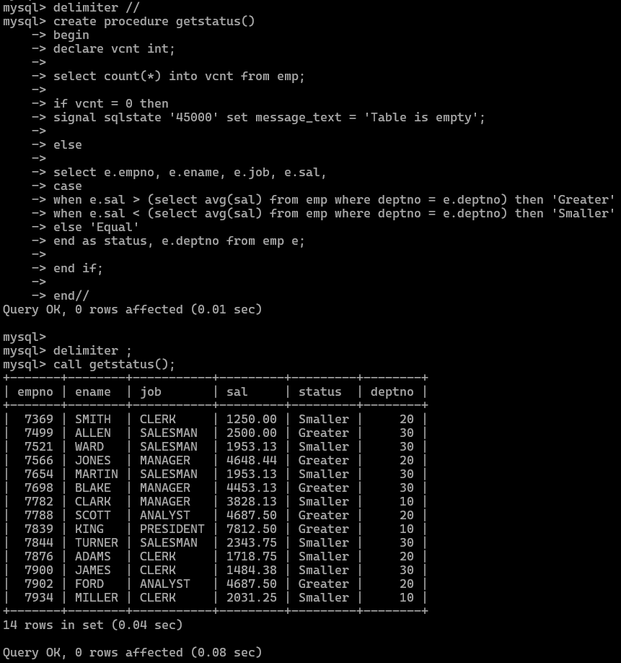

9. Write a procedure to update salary in emp table based on following rules. Exp< =35 then no Update
Exp> 35 and <=38 then 20% of salary
Exp> 38 then 25% of salary
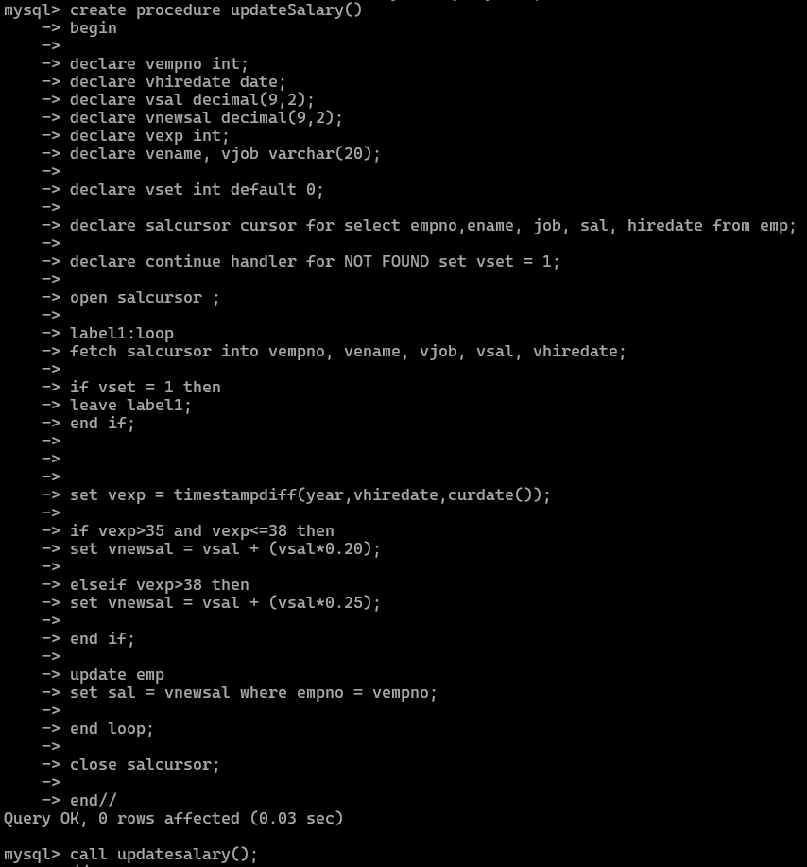
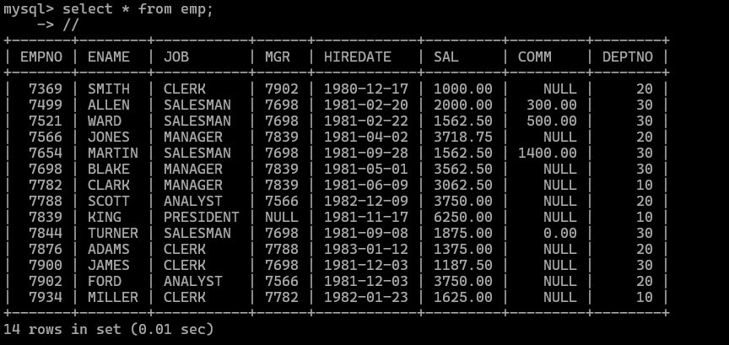
10. Write a procedure and a function.
Function: write a function to calculate number of years of experience of employee.(note: pass hiredate as a parameter)
Procedure: Capture the value returned by the above function to calculate the additional allowance for the emp based on the experience.
Additional Allowance = Year of experience x 3000
Calculate the additional allowance
and store Empno, ename,Date of Joining, and Experience in
years and additional allowance in Emp_Allowance table.
create table emp_allowance(
empno int,
ename varchar(20),
hiredate date,
experience int,
allowance decimal(9,2));
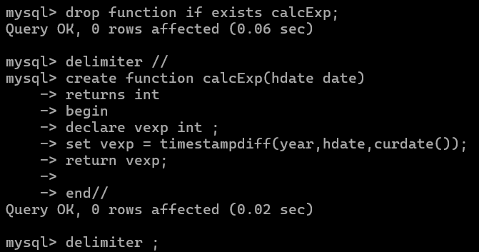
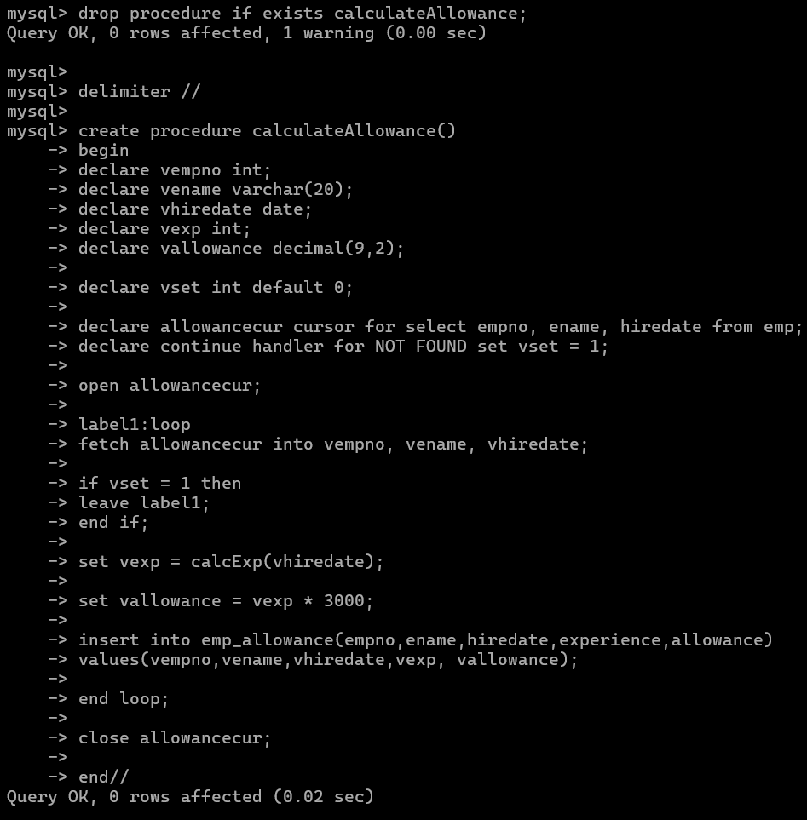
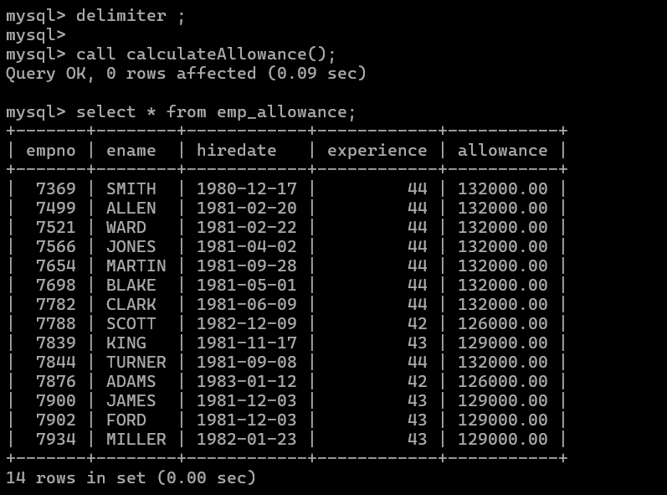

11. Write a function to compute the following. Function should take sal and hiredate as i/p and return the cost to company.
DA = 15% Salary, HRA= 20% of Salary, TA= 8% of Salary.
Special Allowance will be decided based on the service in the company. < 1 Year Nil
>=1 Year< 2 Year 10% of Salary
>=2 Year< 4 Year 20% of Salary
>4 Year 30% of Salary

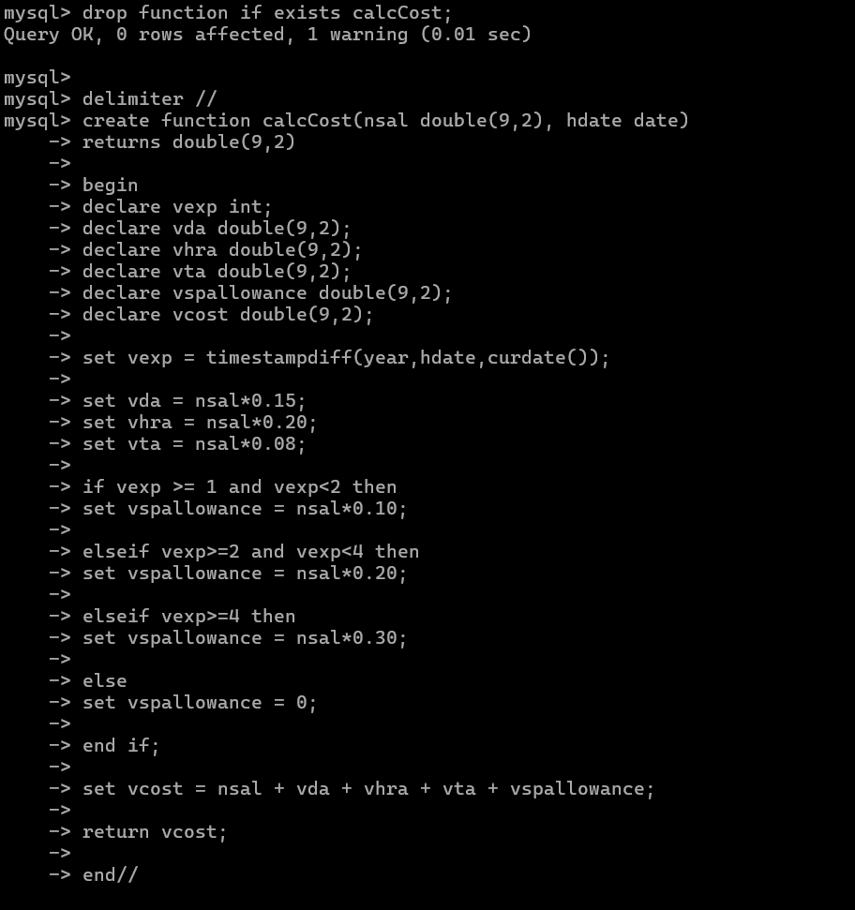
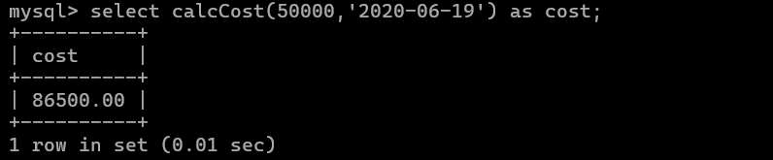

12. Write query to display empno,ename,sal,cost to company for all employees(note: use function written in question 10)
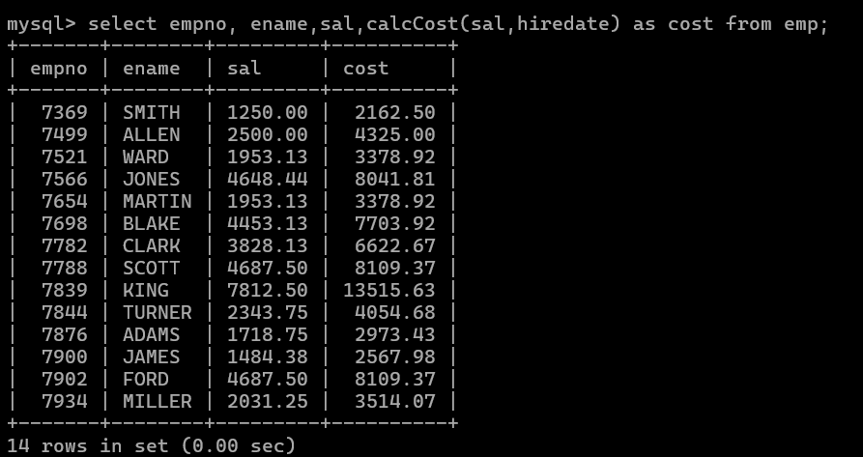

Q2. Write trigger
1. Write a tigger to store the old salary details in Emp _Back (Emp _Back has the same structure as emp table without any
constraint) table.
(note :create emp_back table before writing trigger)
----- to create emp_back table
create table emp_back(
empno int,
ename varchar(20),
oldsal decimal(9,2),
newsal decimal(9,2)
)
(note :
execute procedure written in Q8 and
check the entries in EMP_back table after execution of the procedure)

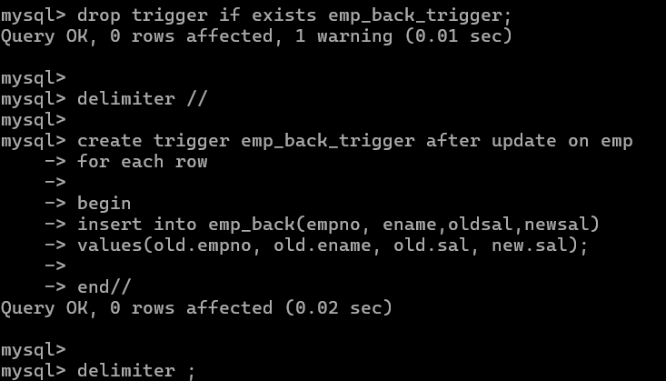
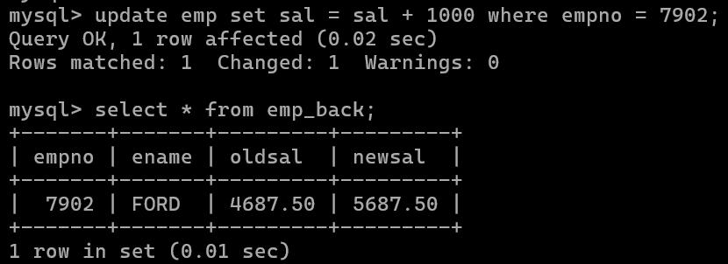
2. Write a trigger which add entry in audit table when user tries to insert or delete records in employee table store empno,name,username and date on which operation performed and which action is done insert or delete. in emp_audit table. create table before writing trigger.
create table empaudit(
empno int;
ename varchar(20),
username varchar(20);
chdate date;
action varchar(20)
);
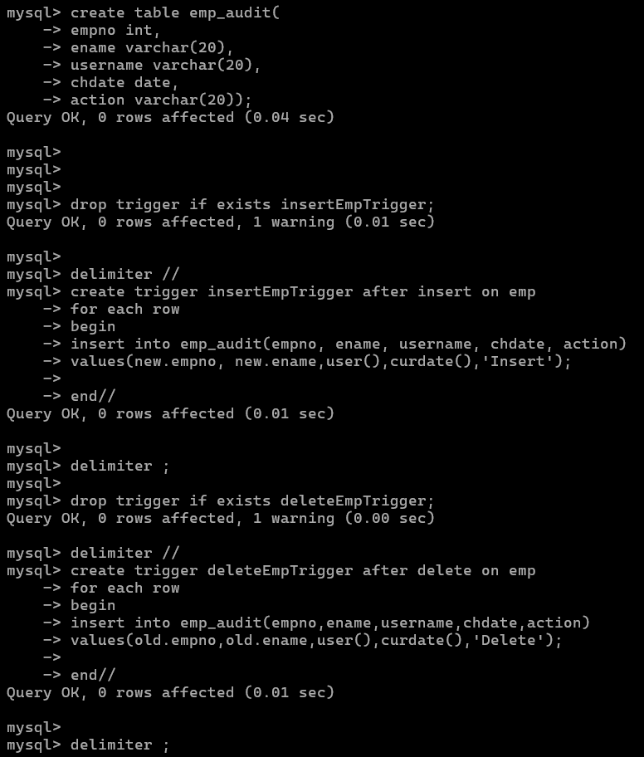
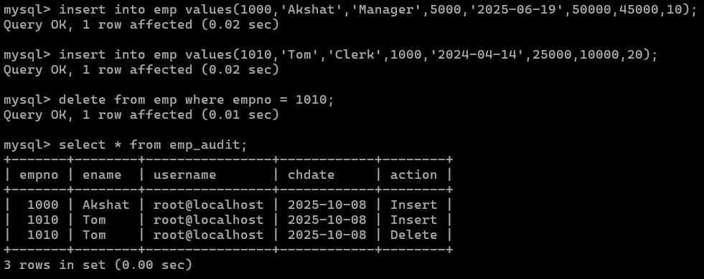

3. Create table vehicle_history. Write a trigger to store old vehicleprice and new vehicle price in history table before you update price in vehicle table
(note: use vehicle table).
create table vehicle_history(
vno int,
vname varchar(20), oldprice decimal(9,2), newprice decimal(9,2), chdate date,
username varchar(20) );

- Write a MongoDB query to display all the documents in the collection restaurants.
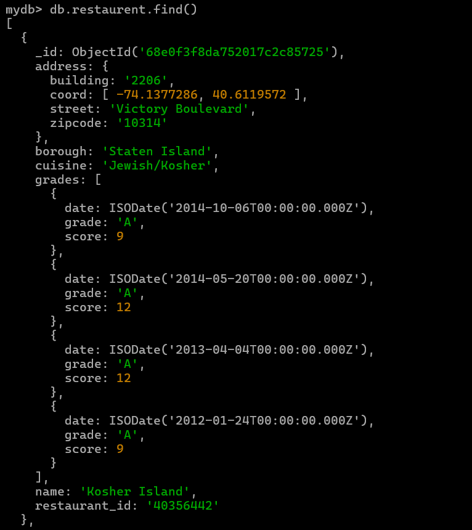
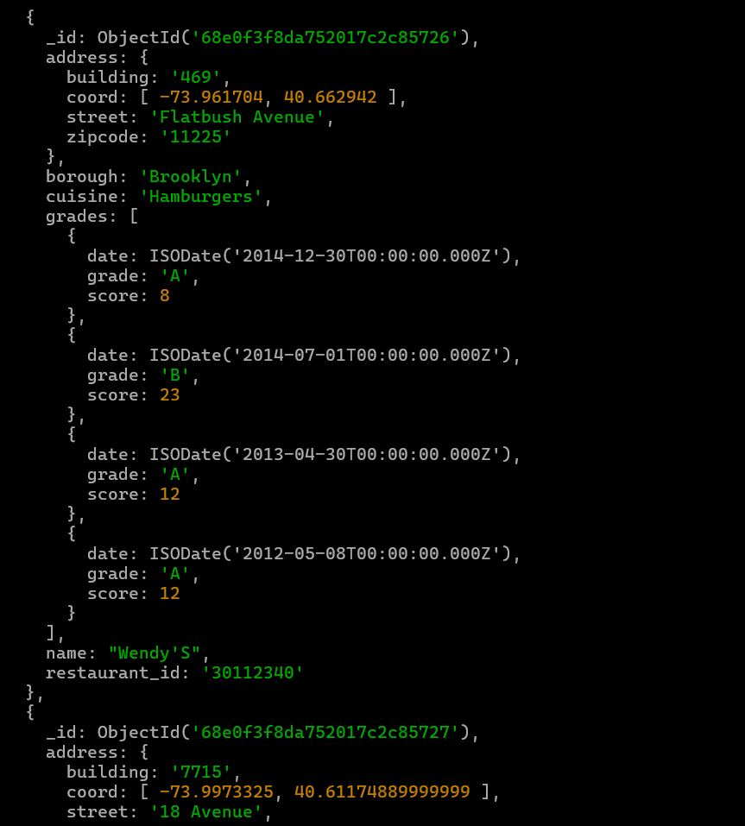

- Write a MongoDB query to display the fields restaurant_id, name, borough and cuisine for all the documents in the collection restaurant.
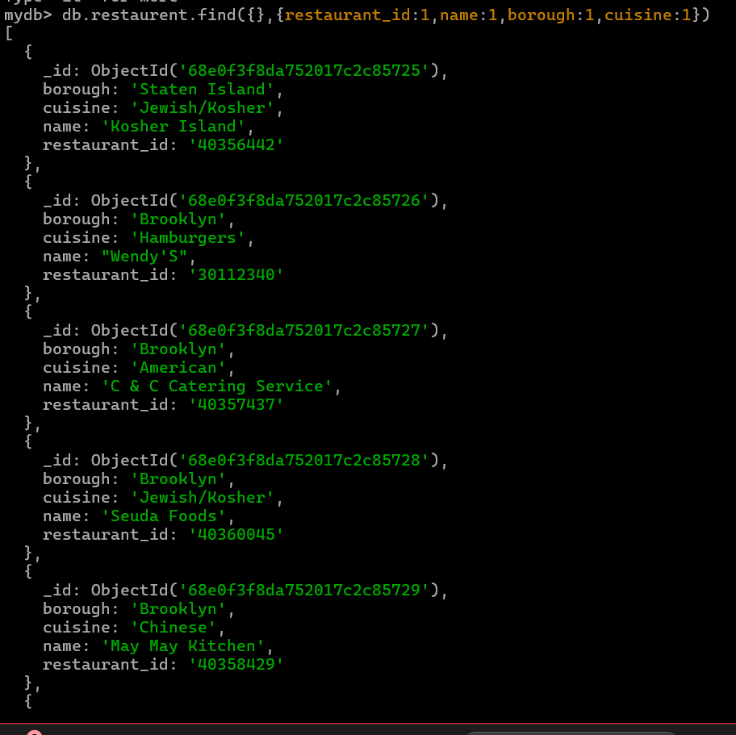

- Write a MongoDB query to display the fields restaurant_id, name, borough and cuisine, but exclude the field _id for all the documents in the collection restaurant.
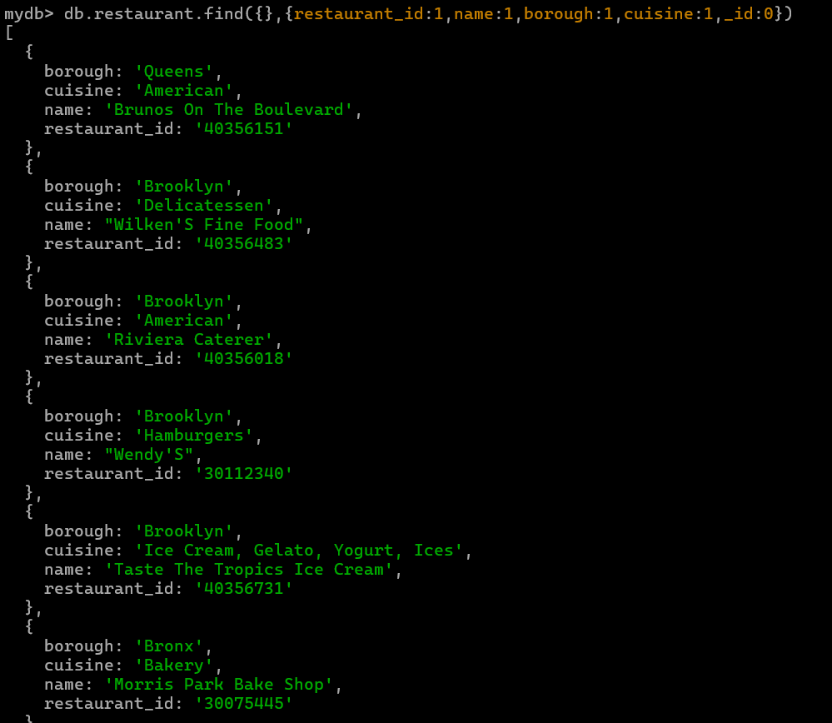

- Write a MongoDB query to display the fields restaurant_id, name, borough and zip code, but exclude the field _id for all the documents in the collection restaurant.
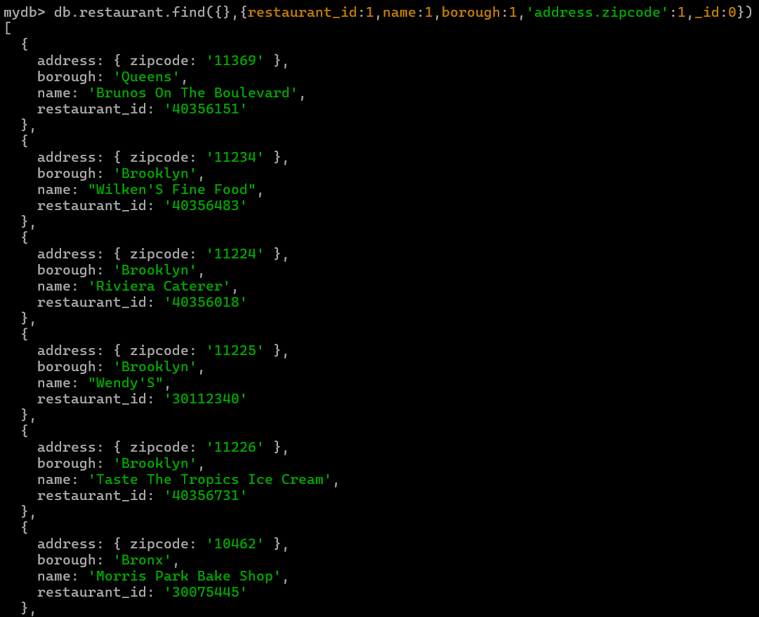

- Write a MongoDB query to display all the restaurant which is in the borough Bronx
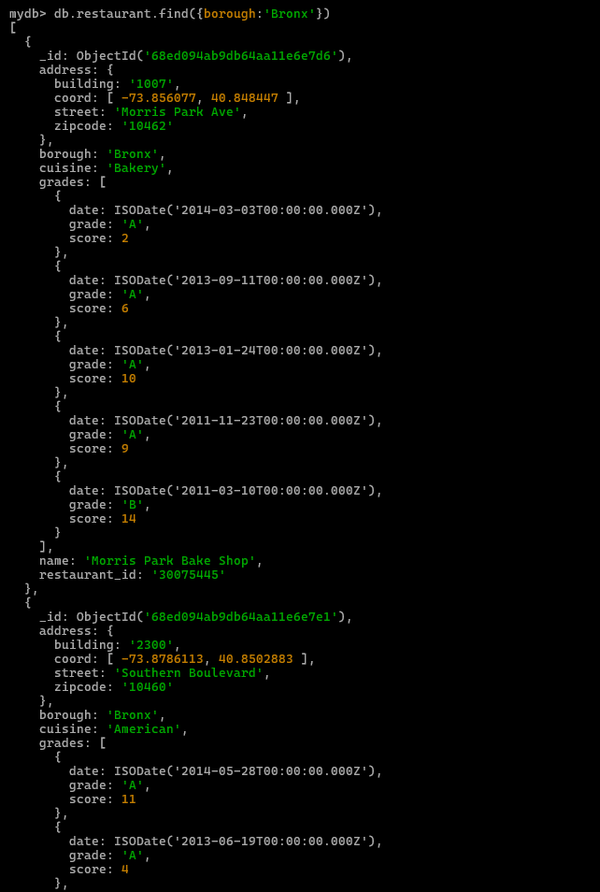
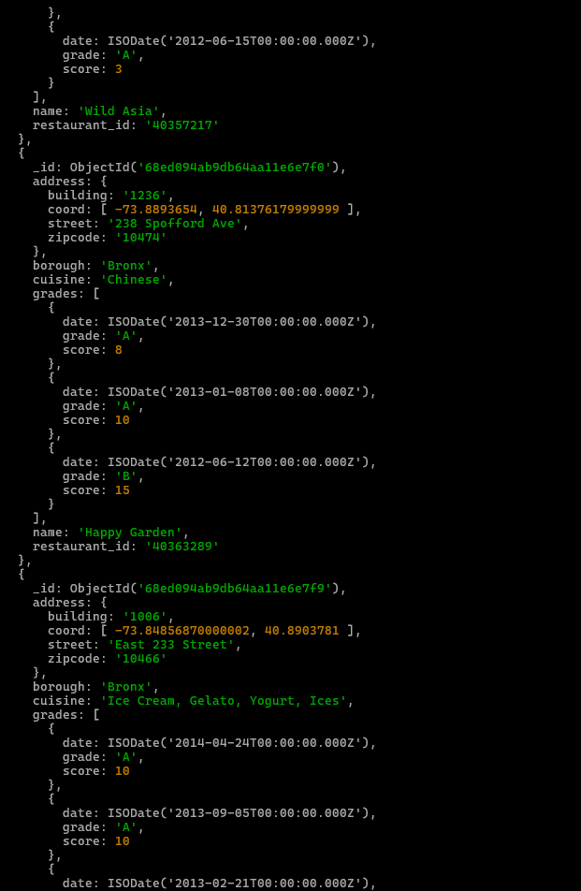
- Write a MongoDB query to display the first 5 restaurant which is in the borough Bronx.
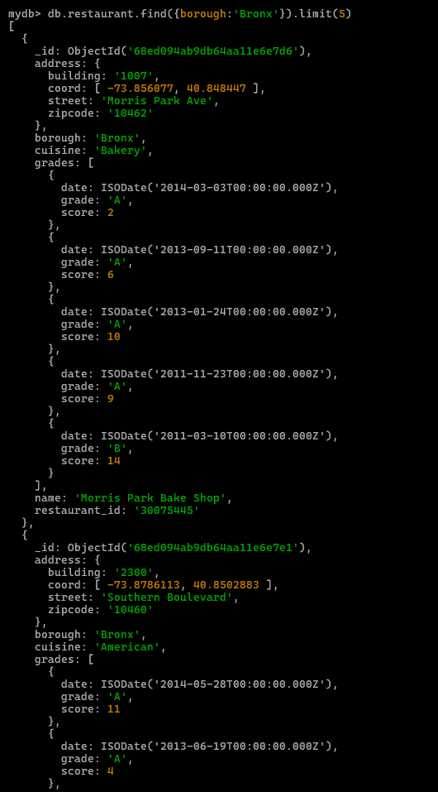
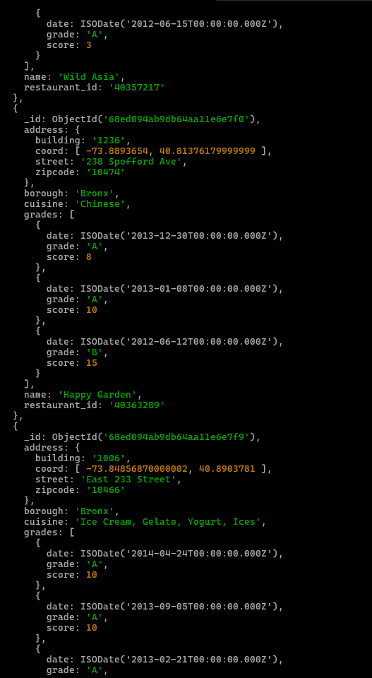
7.Write a MongoDB query to display the next 5 restaurants after skipping first 5 which are in the borough Bronx.
db.restaurant.find({}).limit(5).skip(5)
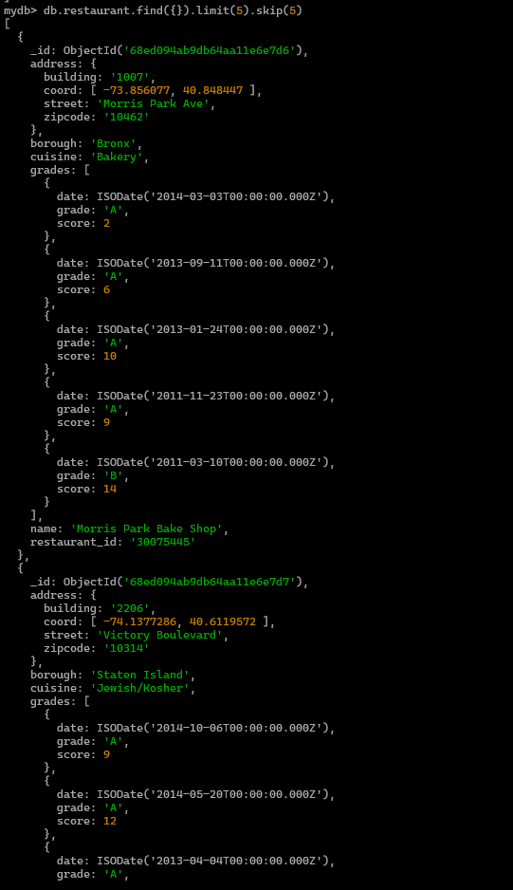
- Write a MongoDB query to find the restaurants who achieved a score more than 90.
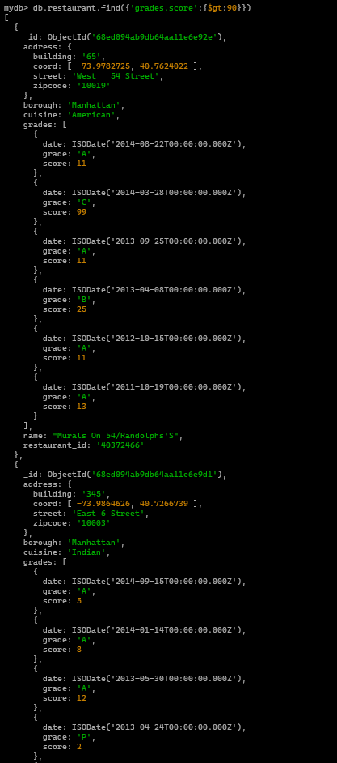
- Write a MongoDB query to find the restaurants that achieved a score, more than 80 but less than 100.
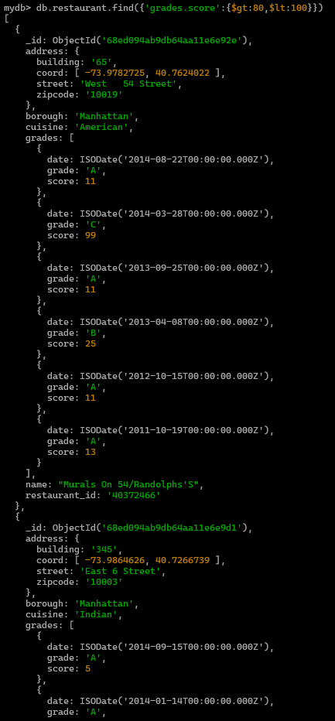
- Write a MongoDB query to find the restaurants which locate in latitude value less than -
95.754168.
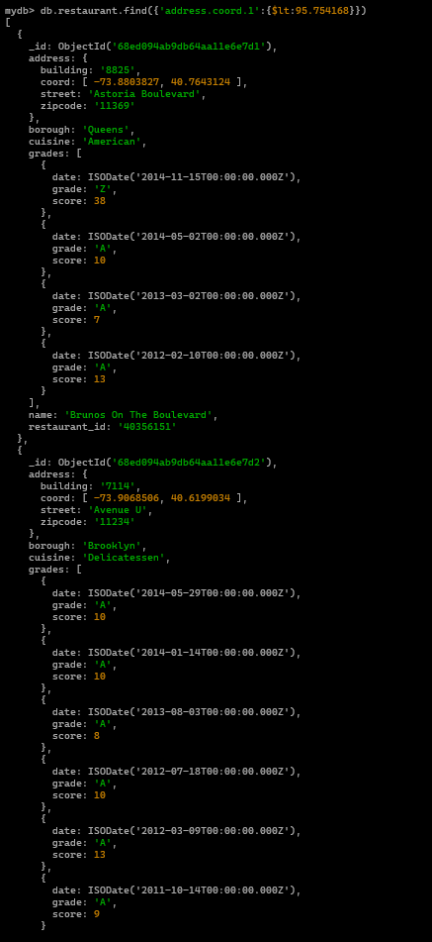
- Write a MongoDB query to find the restaurants that do not prepare any cuisine of 'American' and their grade score more than 70 and latitude less than -65.754168.
db.restaurant.find({cuisine:'American','grades.score':{$gt:70},'address.coord.0':{$lt:-65.754168}})
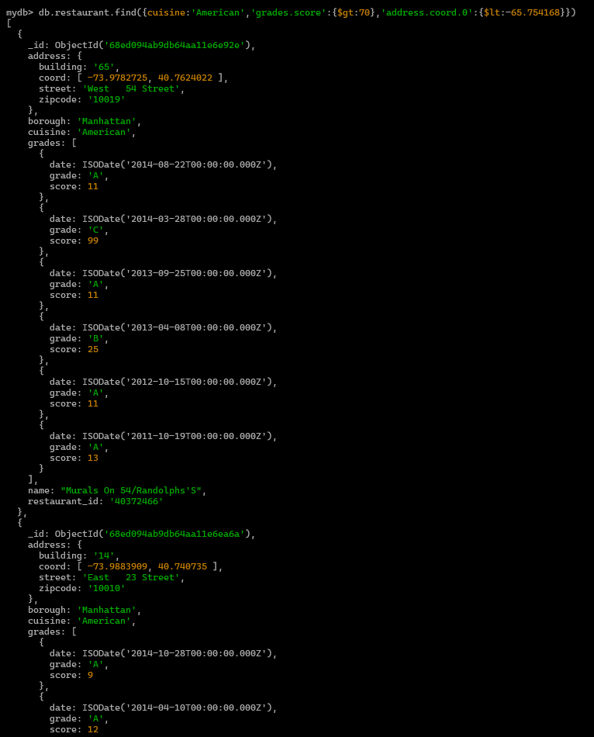
- Write a MongoDB query to find the restaurants which do not prepare any cuisine of 'American' and achieved a score more than 70 and located in the longitude less than 65.754168.

db.restaurant.find({cuisine:{$ne:'American'},'grades.score':{$gt:70},'address.coord.1':{$lt:65.754168}})
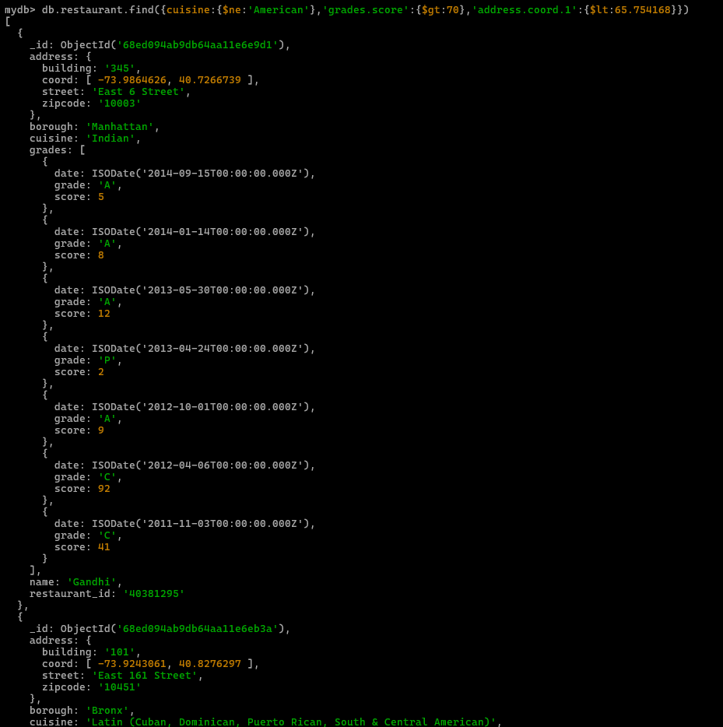
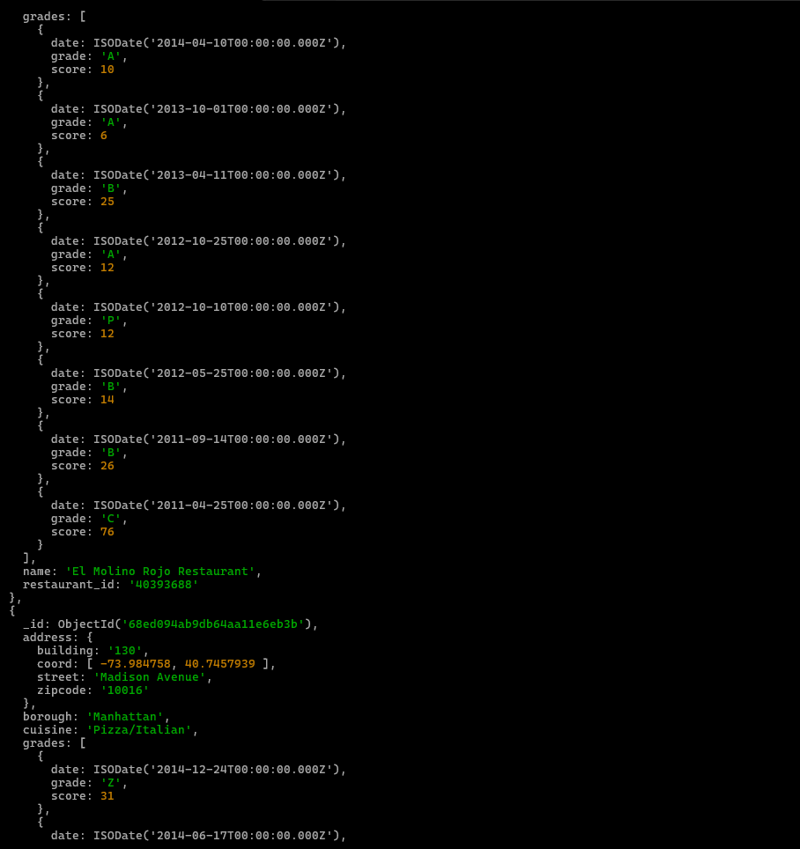

- Write a MongoDB query to find the restaurants which do not prepare any cuisine of 'American ' and achieved a grade point 'A' not belongs to the borough Brooklyn. The document must be displayed according to the cuisine in descending order.
db.restaurant.find({cuisine:{$ne:'American'},'grades.grade':{$eq:'A'},borough:{$ne:'Brooklyn'}})
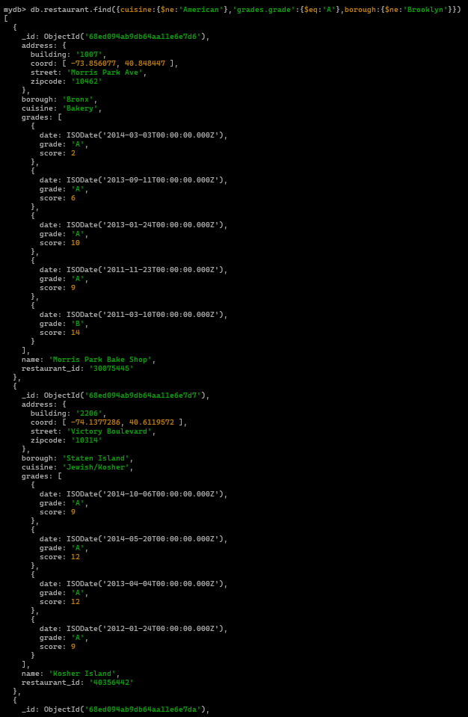
- Write a MongoDB query to find the restaurant Id, name, borough and cuisine for those restaurants which contain 'Wil' as first three letters for its name.
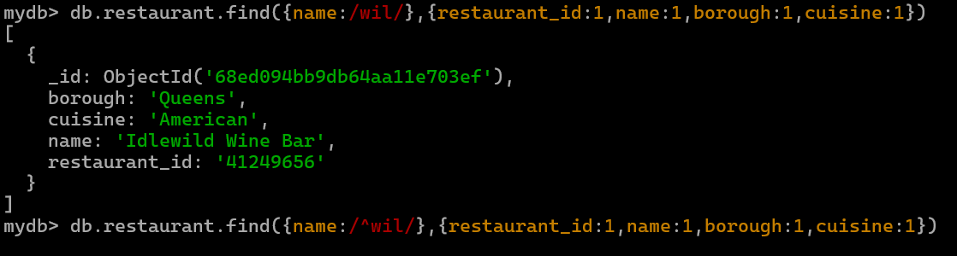
- Write a MongoDB query to find the restaurant Id, name, borough and cuisine for those restaurants which contain 'ces' as last three letters for its name.
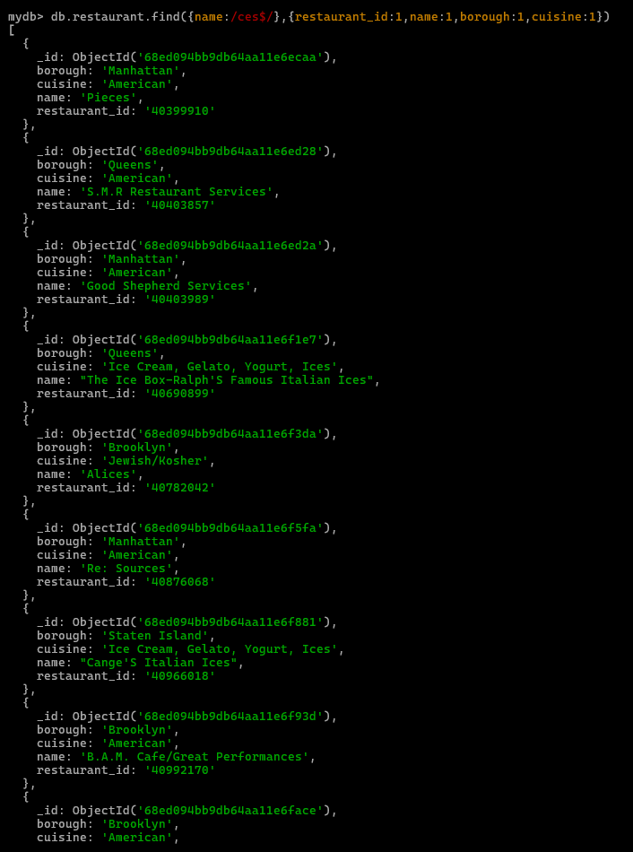
- Write a MongoDB query to find the restaurant Id, name, borough and cuisine for those restaurants which contain 'Reg' as three letters somewhere in its name.
db.restaurant.find({name:/reg/},{restaurant_id:1,name:1,borough:1,cuisine:1})
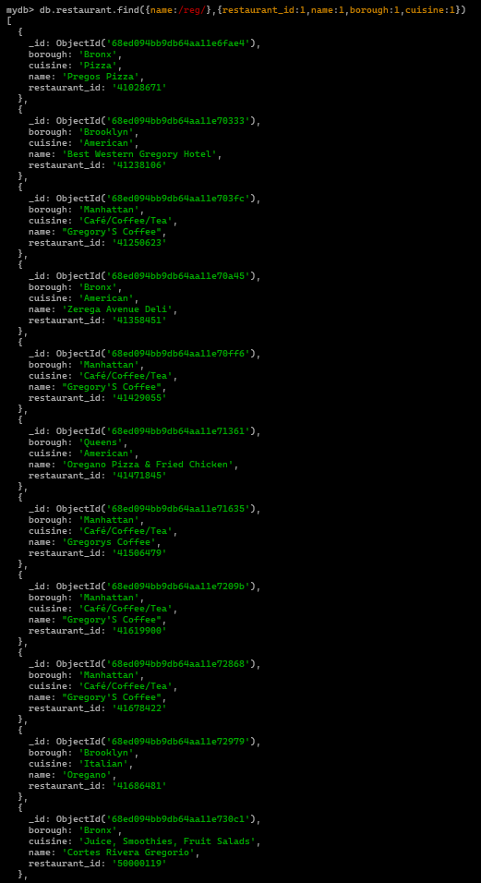
- Write a MongoDB query to find the restaurants which belong to the borough Bronx and prepared either American or Chinese dish.
db.restaurant.find({borough:'Bronx',$or:[{cuisine:'American'},{cuisine:'Chinise'}]})
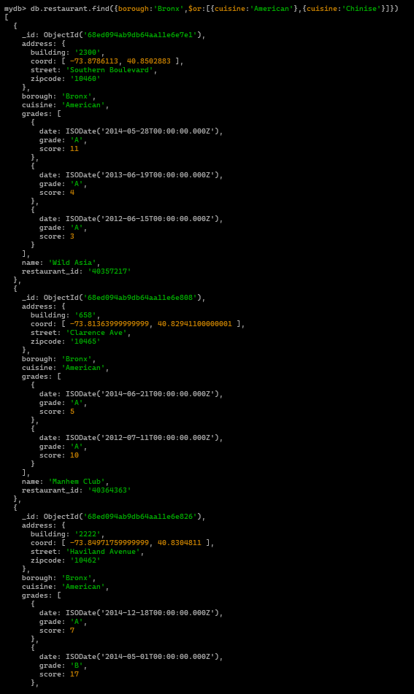
- Write a MongoDB query to find the restaurant Id, name, borough and cuisine for those restaurants which belong to the borough Staten Island or Queens or Bronxor Brooklyn.
db.restaurant.find({$or:[{borough:'Staten Island'},{borough:'Queens'},{borough:'Brooklyn'}]},{restaurant_id:1,name:1,borough:1,cuisine:1})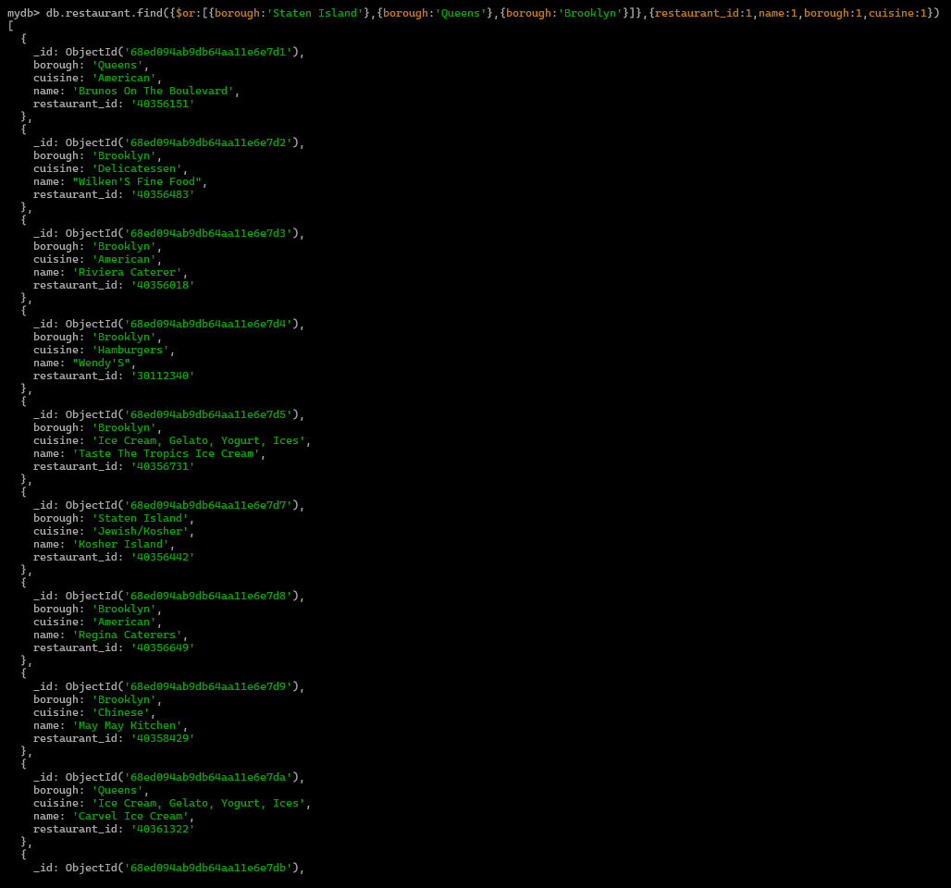

- Write a MongoDB query to find the restaurant Id, name, borough and cuisine for those restaurants which are not belonging to the borough Staten Island or Queens or Bronxor Brooklyn.
db.restaurant.find({borough:{$nin:['Staten Island','Queens','Brooklyn','Bronx']}},{restaurant_id:1,name:1,borough:1,cuisine:1})
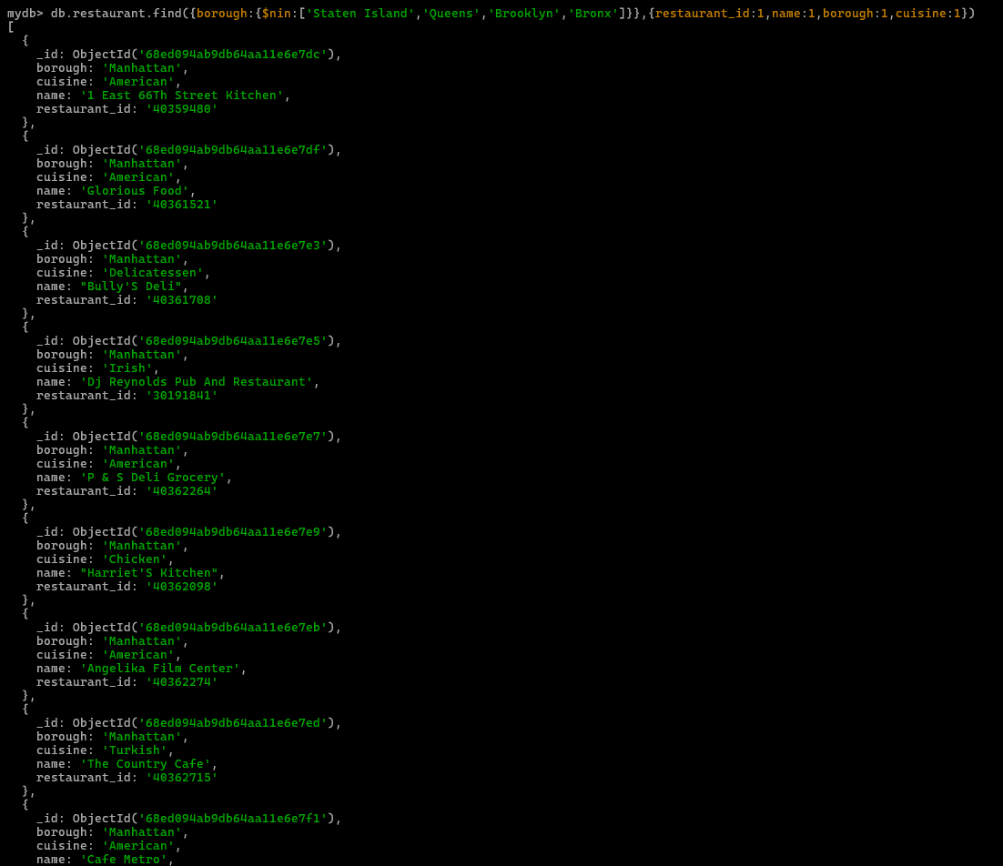
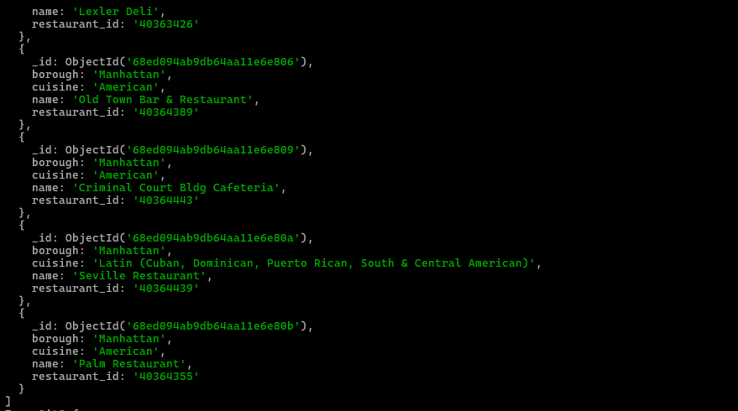
- Write a MongoDB query to find the restaurant Id, name, borough and cuisine for those restaurants which achieved a score which is not more than 10.
db.restaurant.find({'grades.score':{$lte:10}},{restaurant_id:1,name:1,borough:1,cuisine:1})
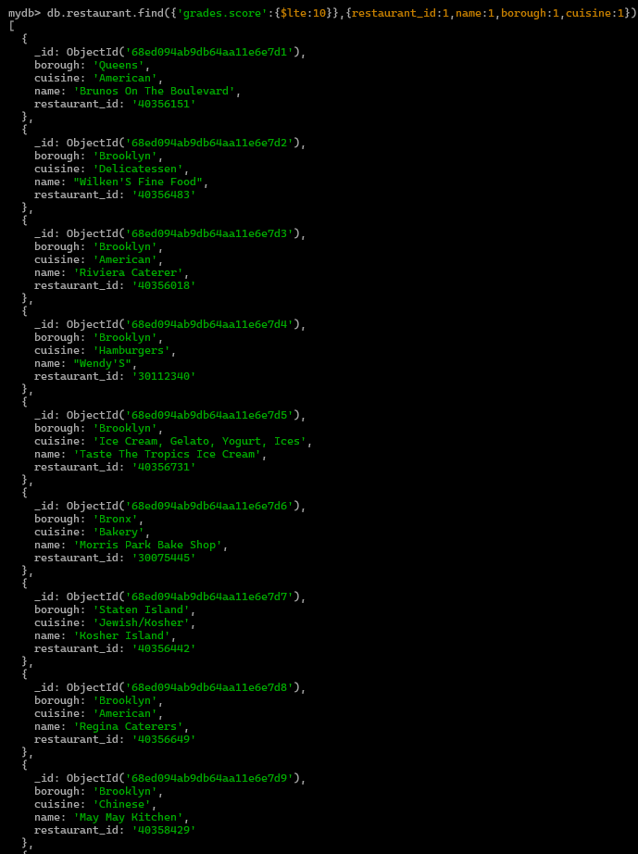
- Write a MongoDB query to find the restaurant Id, name, borough and cuisine for those restaurants which prepared dish except 'American' and 'Chinees' or restaurant's name begins with letter 'Wil'.
db.restaurant.find({$or:[{borough:{$nin:['American','Chinese']}},{name:/^wil/}]},{restaurant_id:1,name:1,borough:1,cuisine:1})
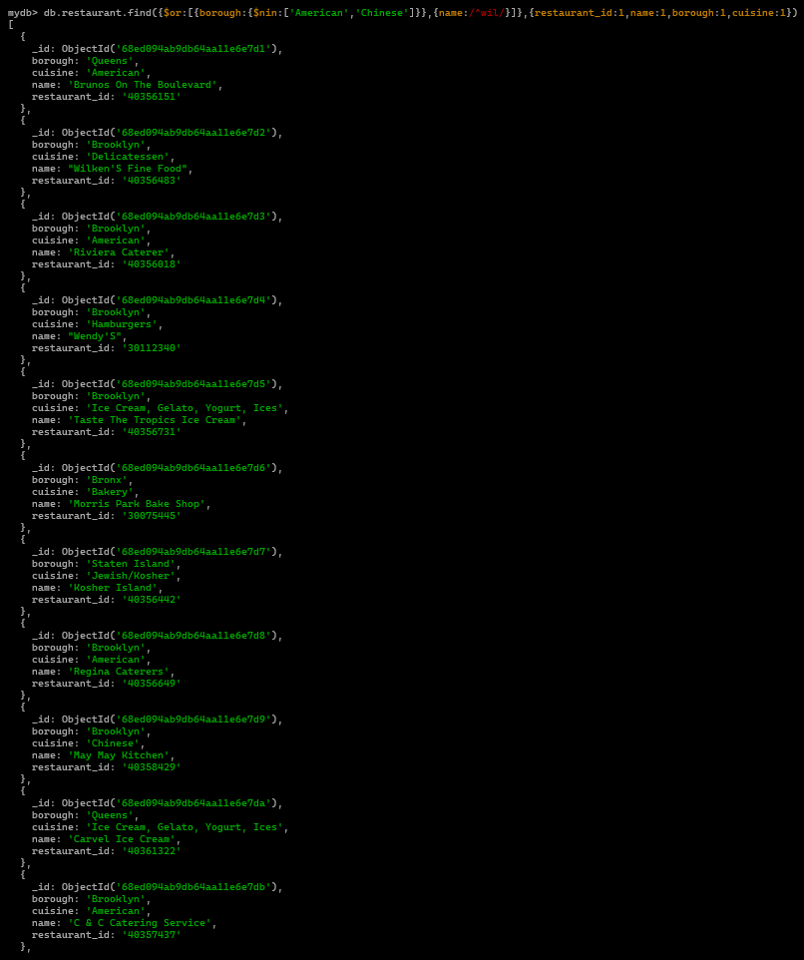

- Write a MongoDB query to find the restaurant Id, name, and grades for those restaurants which achieved a grade of "A" and scored 11 on an ISODate "2014-08-11T00:00:00Z" among many of survey dates.
db.restaurant.find({'grades':{$elemMatch:{'date':ISODate("2014-08-11T00:00:00Z"),'grade':'A','score':11}}},{_id:0,restaurant_id:1,name:1,grades:1})
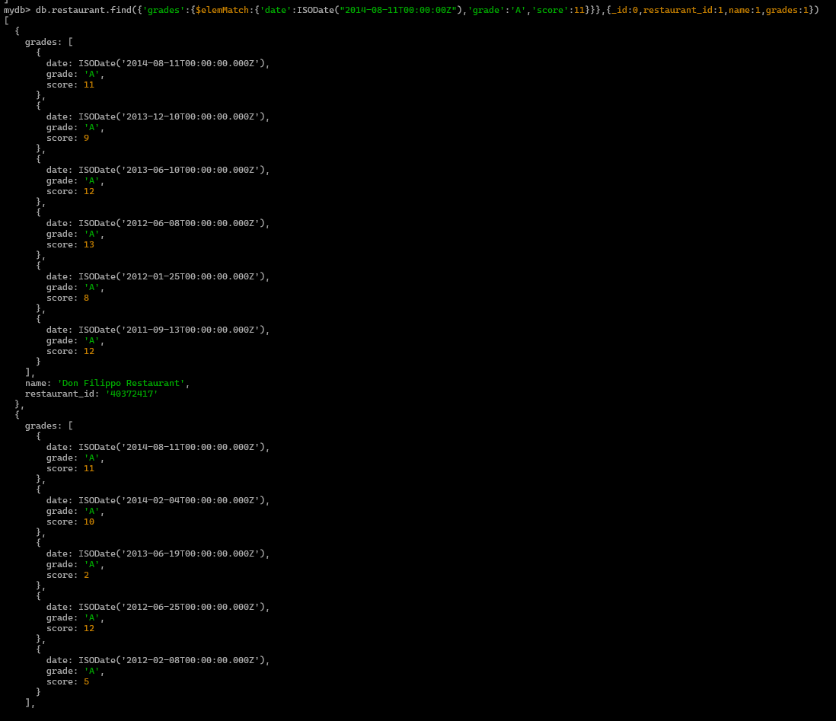
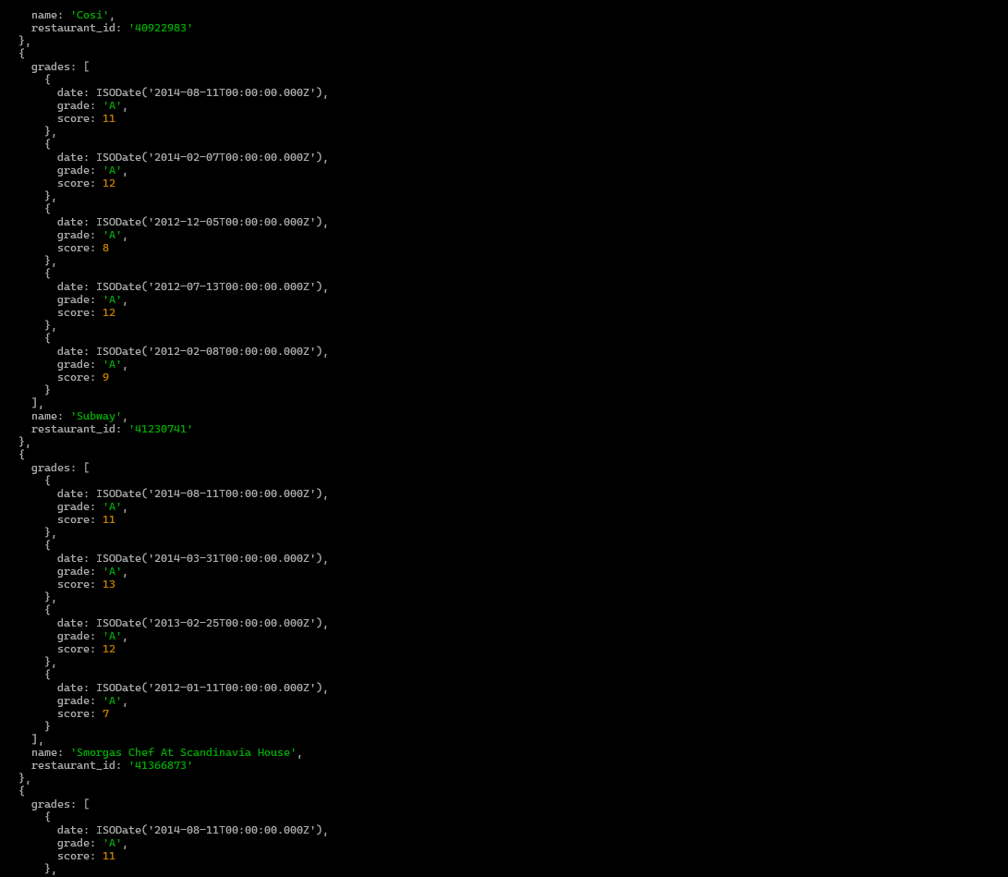

- Write a MongoDB query to find the restaurant Id, name and grades for those restaurants where the 2nd element of grades array contains a grade of "A" and score 9 on an ISODate "2014-08-11T00:00:00Z".
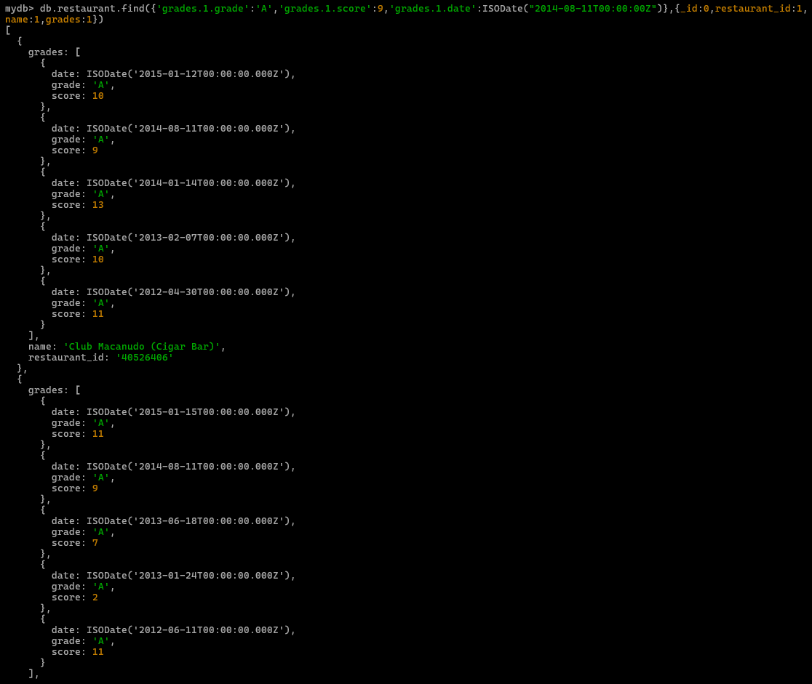

- Write a MongoDB query to find the restaurant Id, name, address and geographical location for those restaurants where 2nd element of coord array contains a value which is more than 42 and upto 52
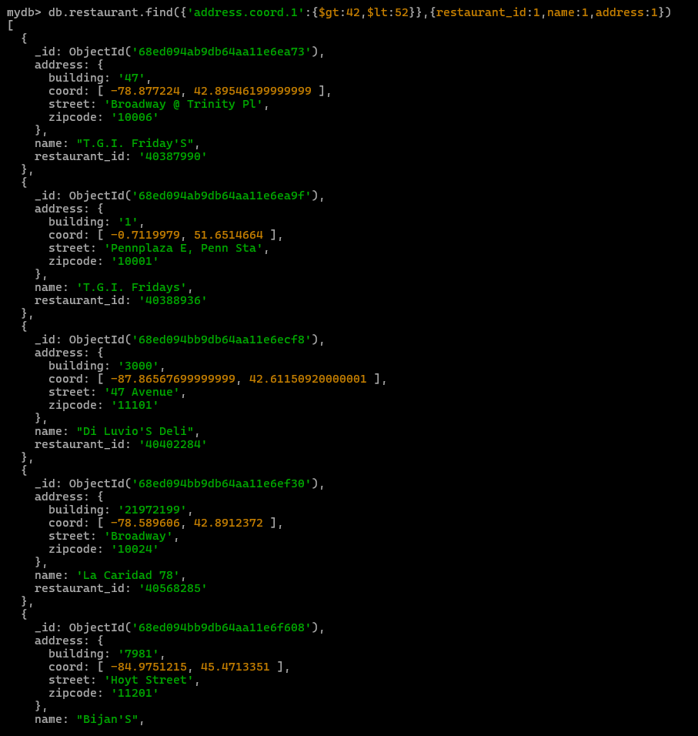
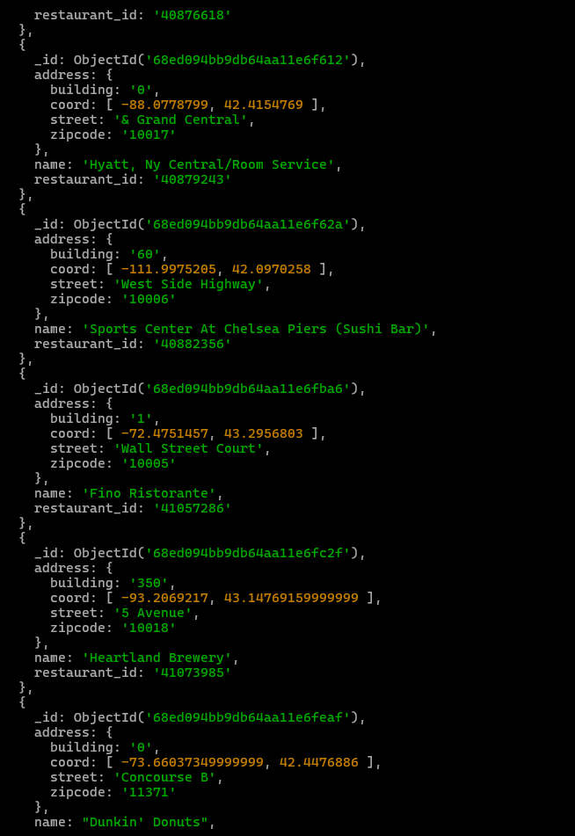
- Write a MongoDB query to arrange the name of the restaurants in ascending order along with all the columns.
db.restaurant.find({name:{$ne:'' }}).sort({name:1})
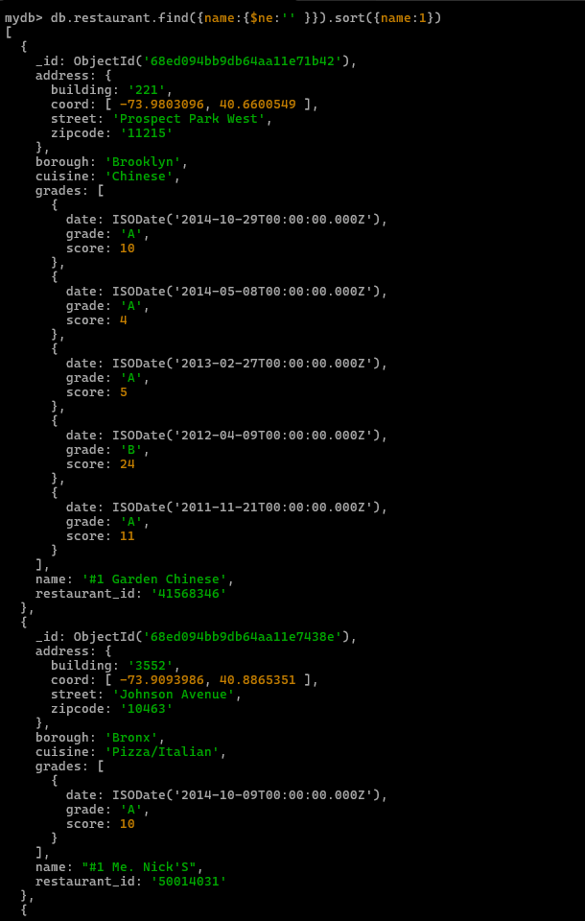

db.restaurant.find({name:{$ne:'' }},{_id:0,name:1}).sort({name:1})
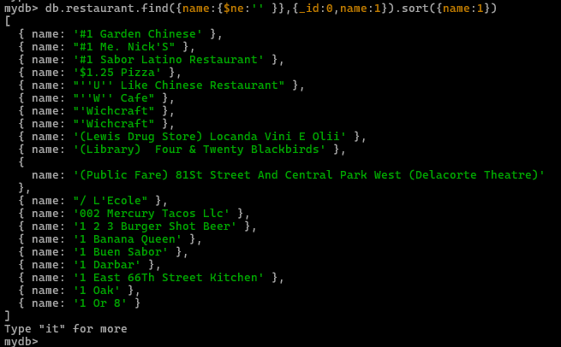

- Write a MongoDB query to arrange the name of the restaurants in descending along with all the columns.
db.restaurant.find({name:{$ne:'' }}).sort({name:-1})
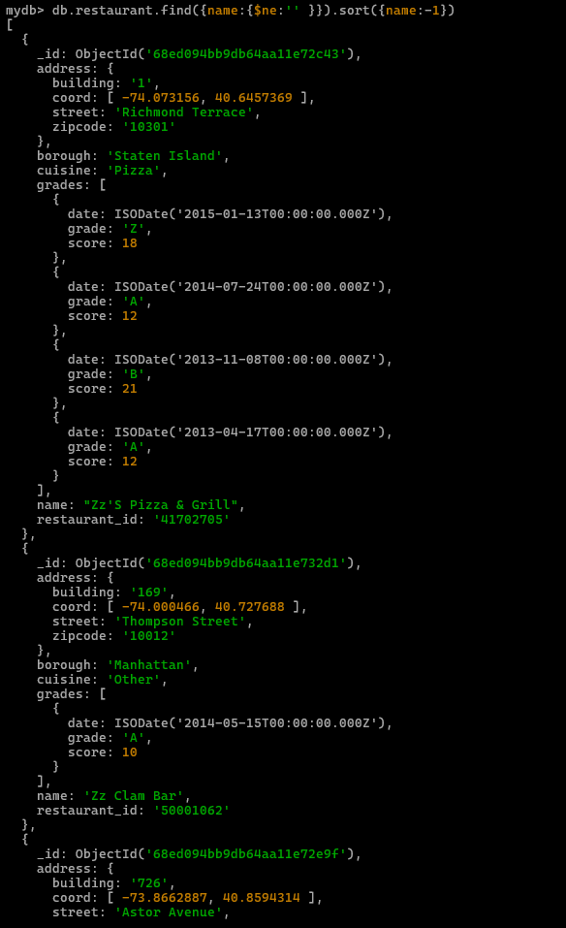
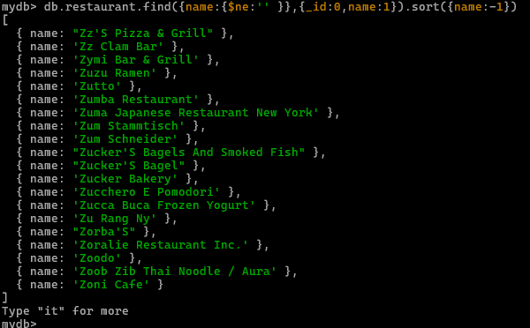

- Write a MongoDB query to arranged the name of the cuisine in ascending order and for that same cuisine borough should be in descending order.
db.restaurant.find().sort({cuisine:1,borough:-1})
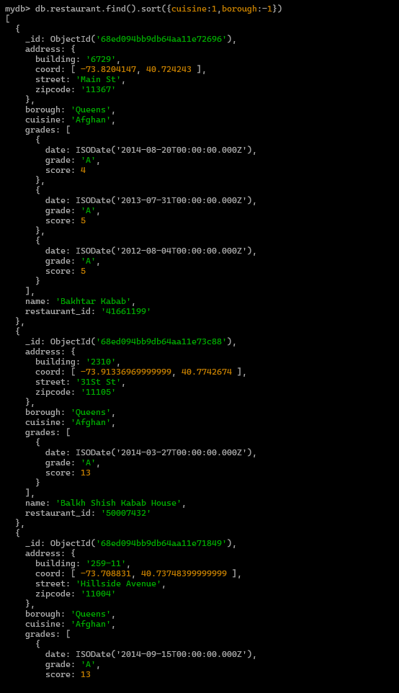
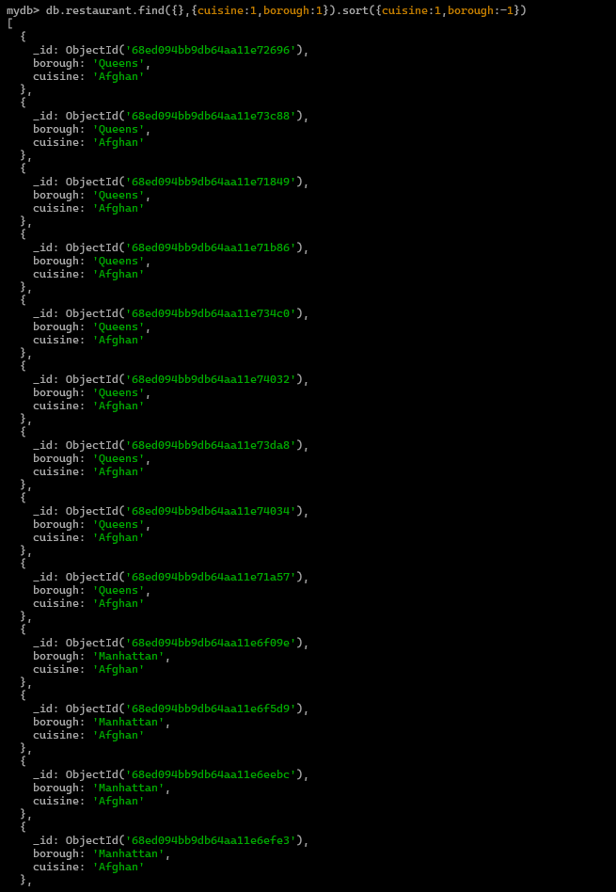

- Write a MongoDB query to know whether all the addresses contains the street or not.
db.restaurant.find({ 'address.street': { $exists: false } })

- Write a MongoDB query which will select all documents in the restaurants collection where the coord field value is Double.
db.restaurant.find({'address.coord':{$type:1}})
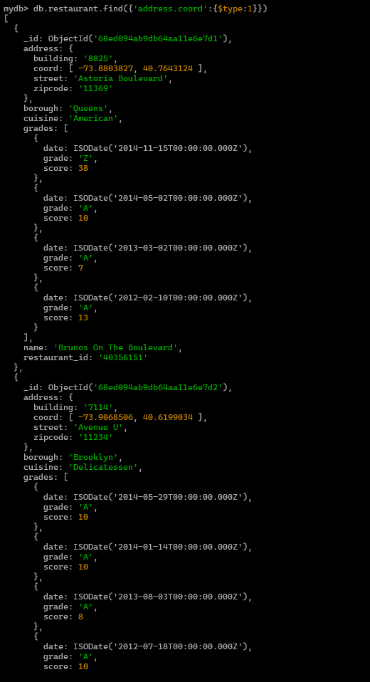
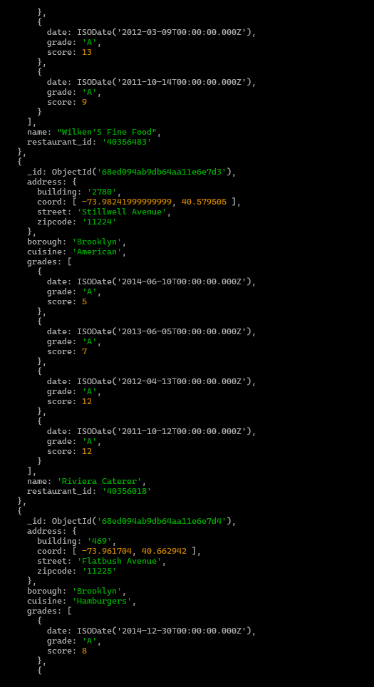
- Write a MongoDB query which will select the restaurant Id, name and grades for those restaurants which returns 0 as a remainder after dividing the score by 7.
db.restaurant.find({'grades.score':{$mod:[7,0]}},{_id:0,restaurant_id:1,name:1,grades:1})
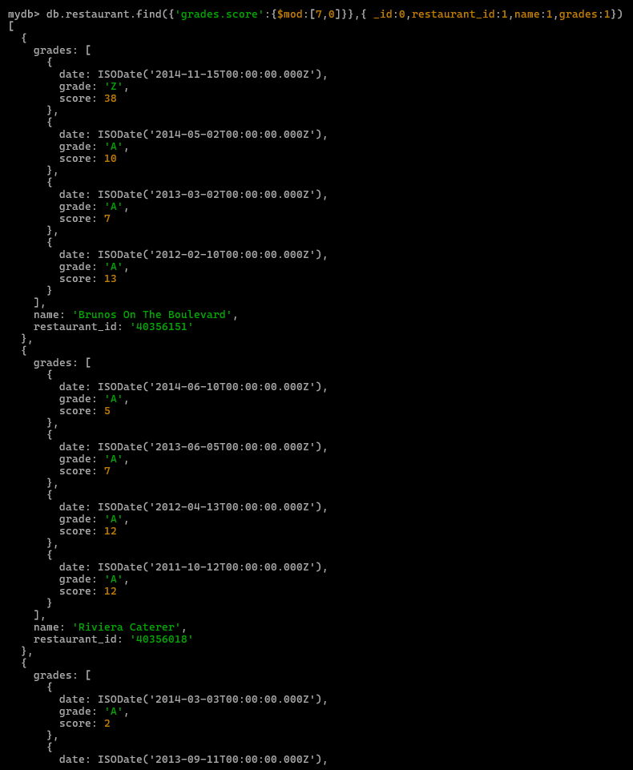
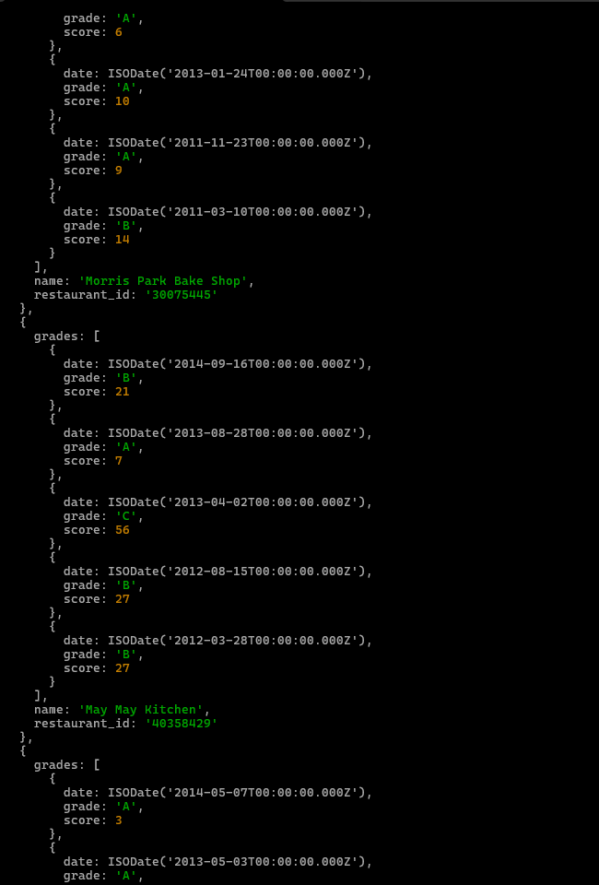
- Write a MongoDB query to find the restaurant name, borough, longitude and attitude and cuisine for those restaurants which contains 'mon' as three letters somewhere in its name.
db.restaurant.find({name:/mon/},{_id:0,name:1,borough:1,'address.coord':1,cuisine:1})
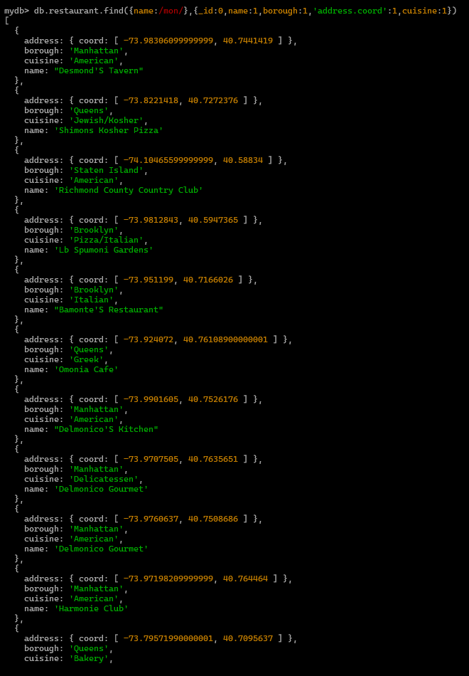
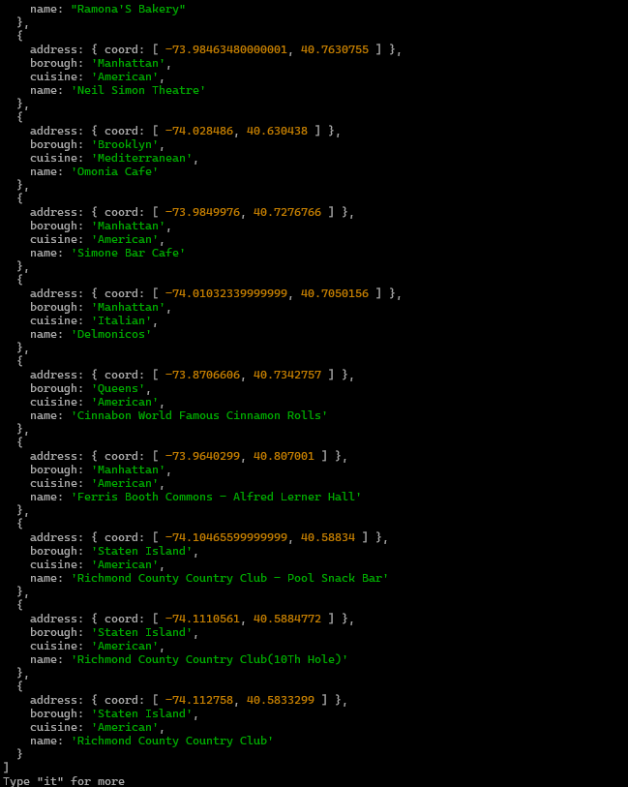

- Write a MongoDB query to find the restaurant name, borough, longitude and latitude and cuisine for those restaurants which contain 'Mad' as first three letters of its name.
db.restaurant.find({name:/^mad/i},{_id:0,name:1,borough:1,'address.coord':1,cuisine:1})
